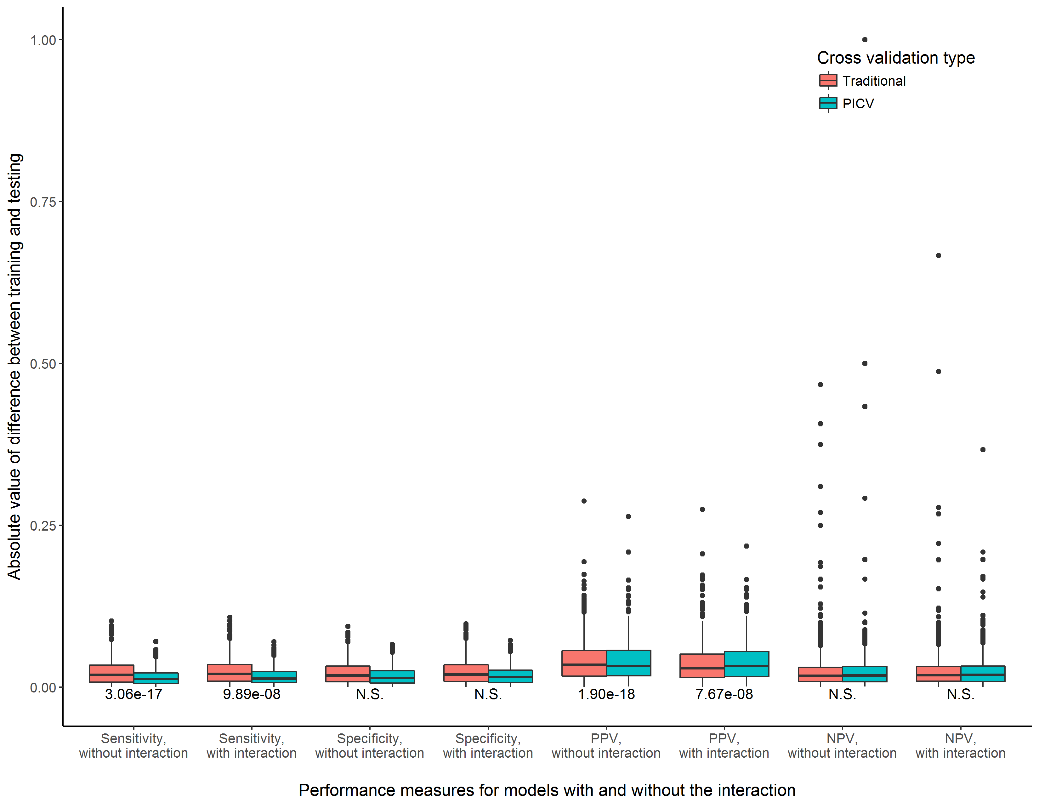

**Supplemental Figure 1.** Consistency of training and testing performance measures for models with and without the interaction term, comparing a traditional cross validation procedure to PICV. Experimental scenario 1, n = 2000

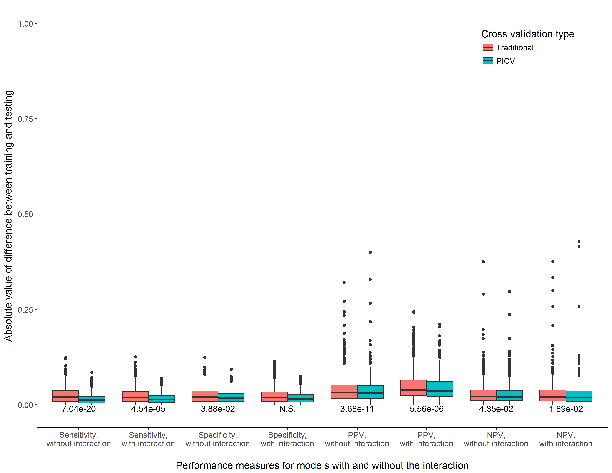

**Supplemental Figure 2.** Consistency of training and testing performance measures for models with and without the interaction term, comparing a traditional cross validation procedure to PICV. Experimental scenario 2, n = 2000

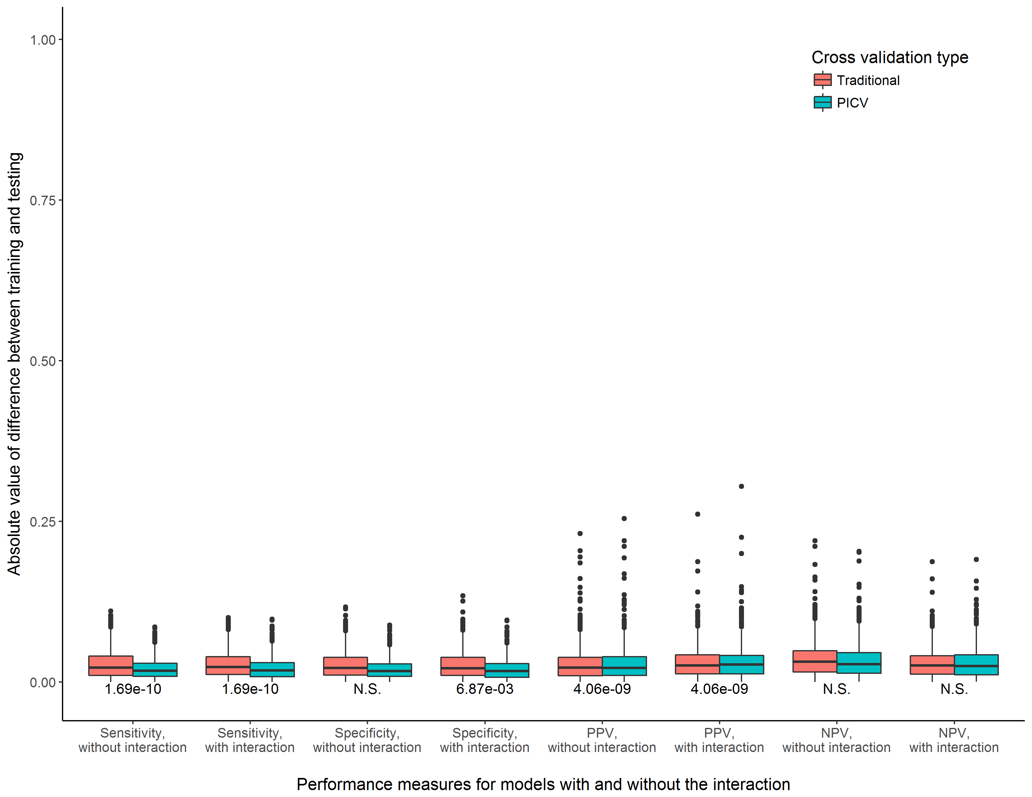

**Supplemental Figure 3.** Consistency of training and testing performance measures for models with and without the interaction term, comparing a traditional cross validation procedure to PICV. Experimental scenario 3, n = 2000

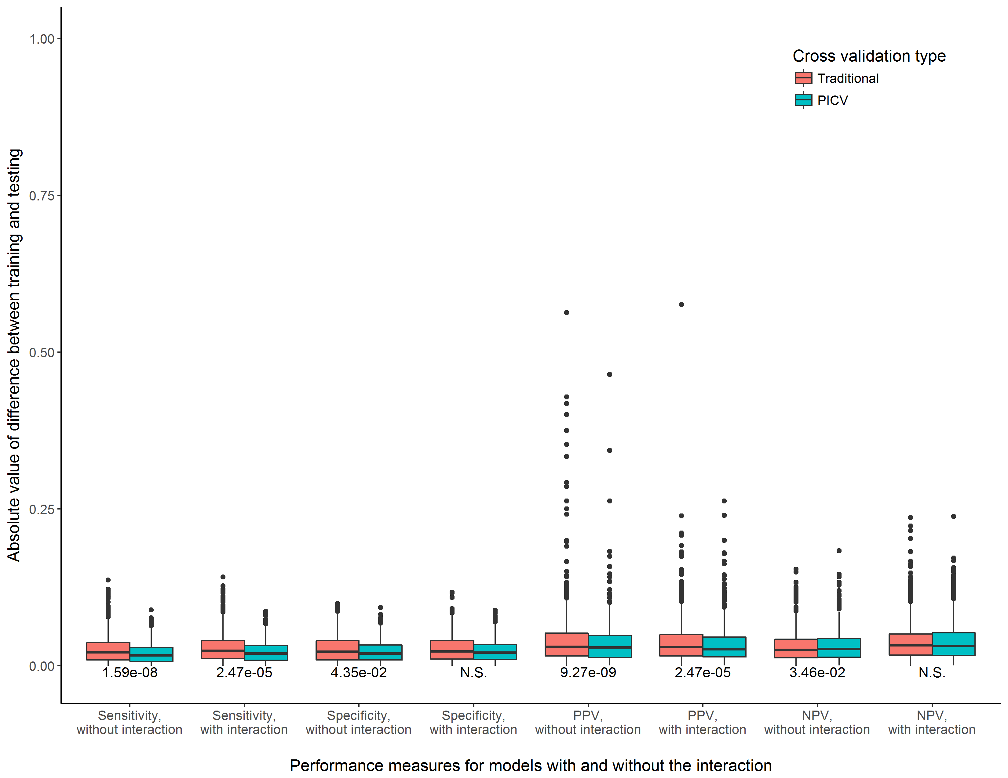

**Supplemental Figure 4.** Consistency of training and testing performance measures for models with and without the interaction term, comparing a traditional cross validation procedure to PICV. Experimental scenario 4, n = 2000

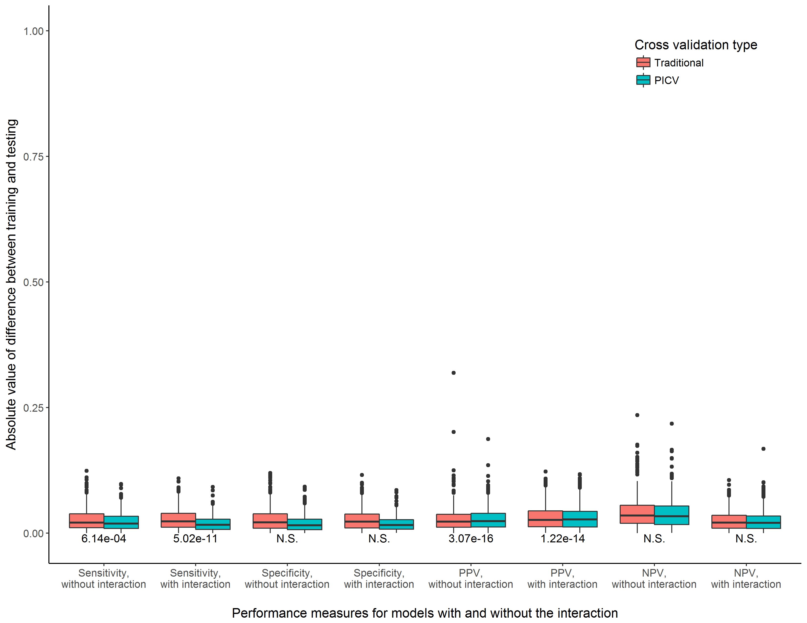

**Supplemental Figure 5.** Consistency of training and testing performance measures for models with and without the interaction term, comparing a traditional cross validation procedure to PICV. Experimental scenario 5, n = 2000

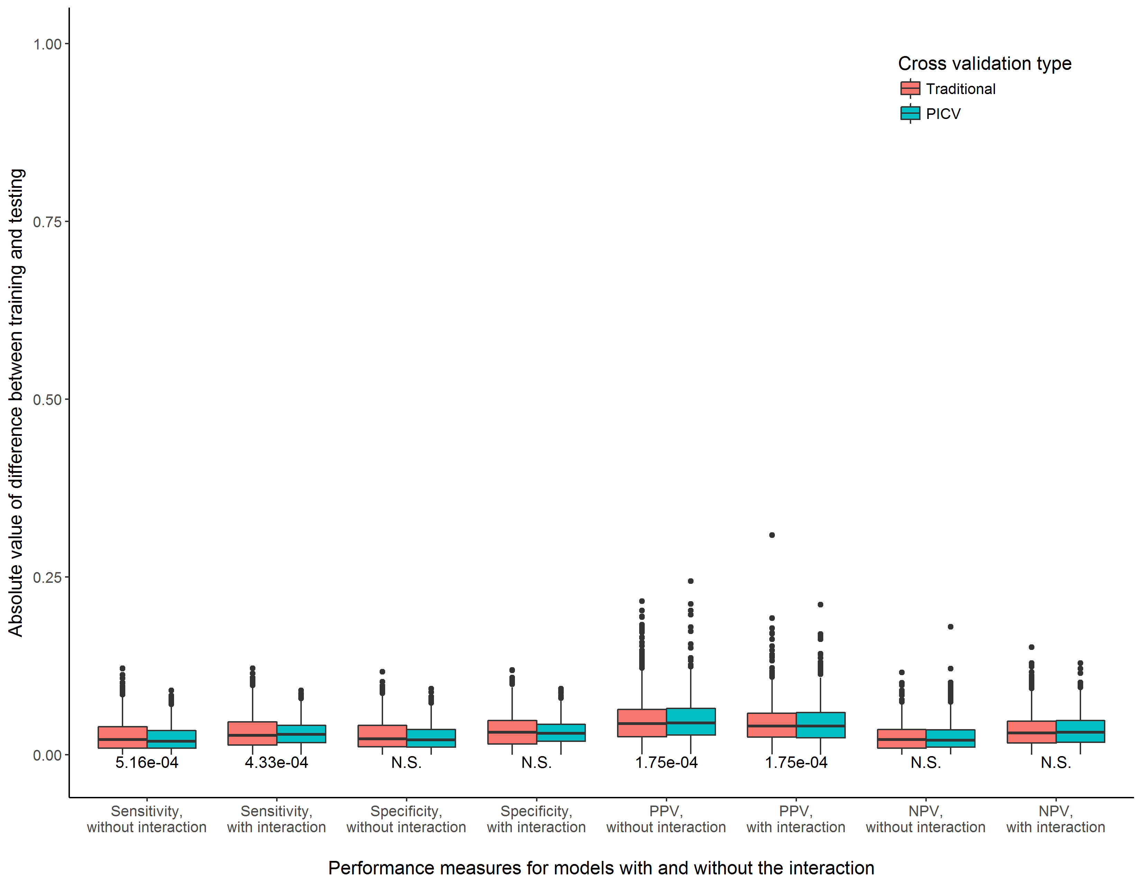

**Supplemental Figure 6.** Consistency of training and testing performance measures for models with and without the interaction term, comparing a traditional cross validation procedure to PICV. Experimental scenario 6, n = 2000

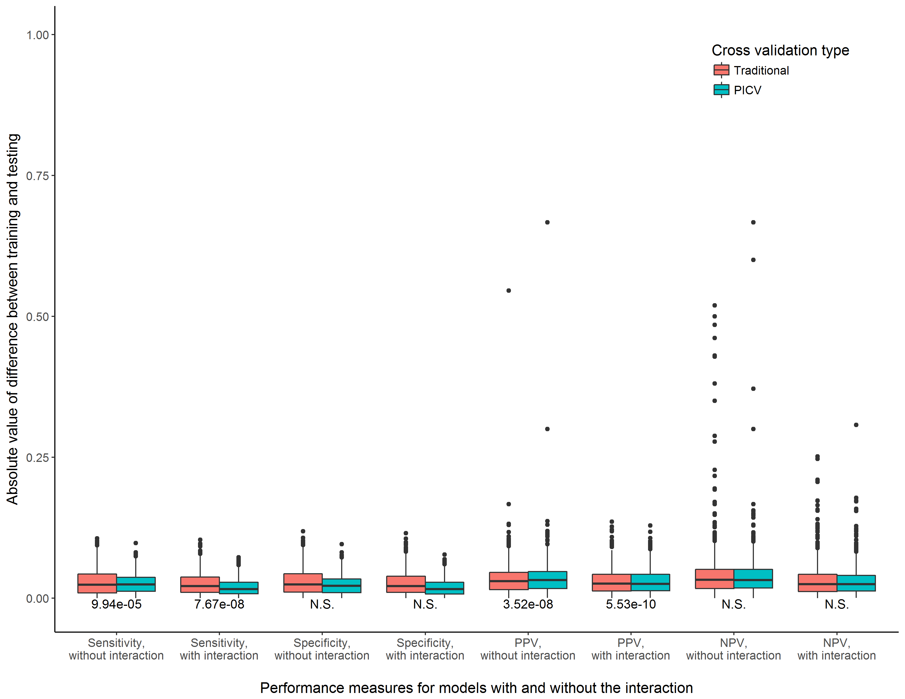

**Supplemental Figure 7.** Consistency of training and testing performance measures for models with and without the interaction term, comparing a traditional cross validation procedure to PICV. Experimental scenario 7, n = 2000

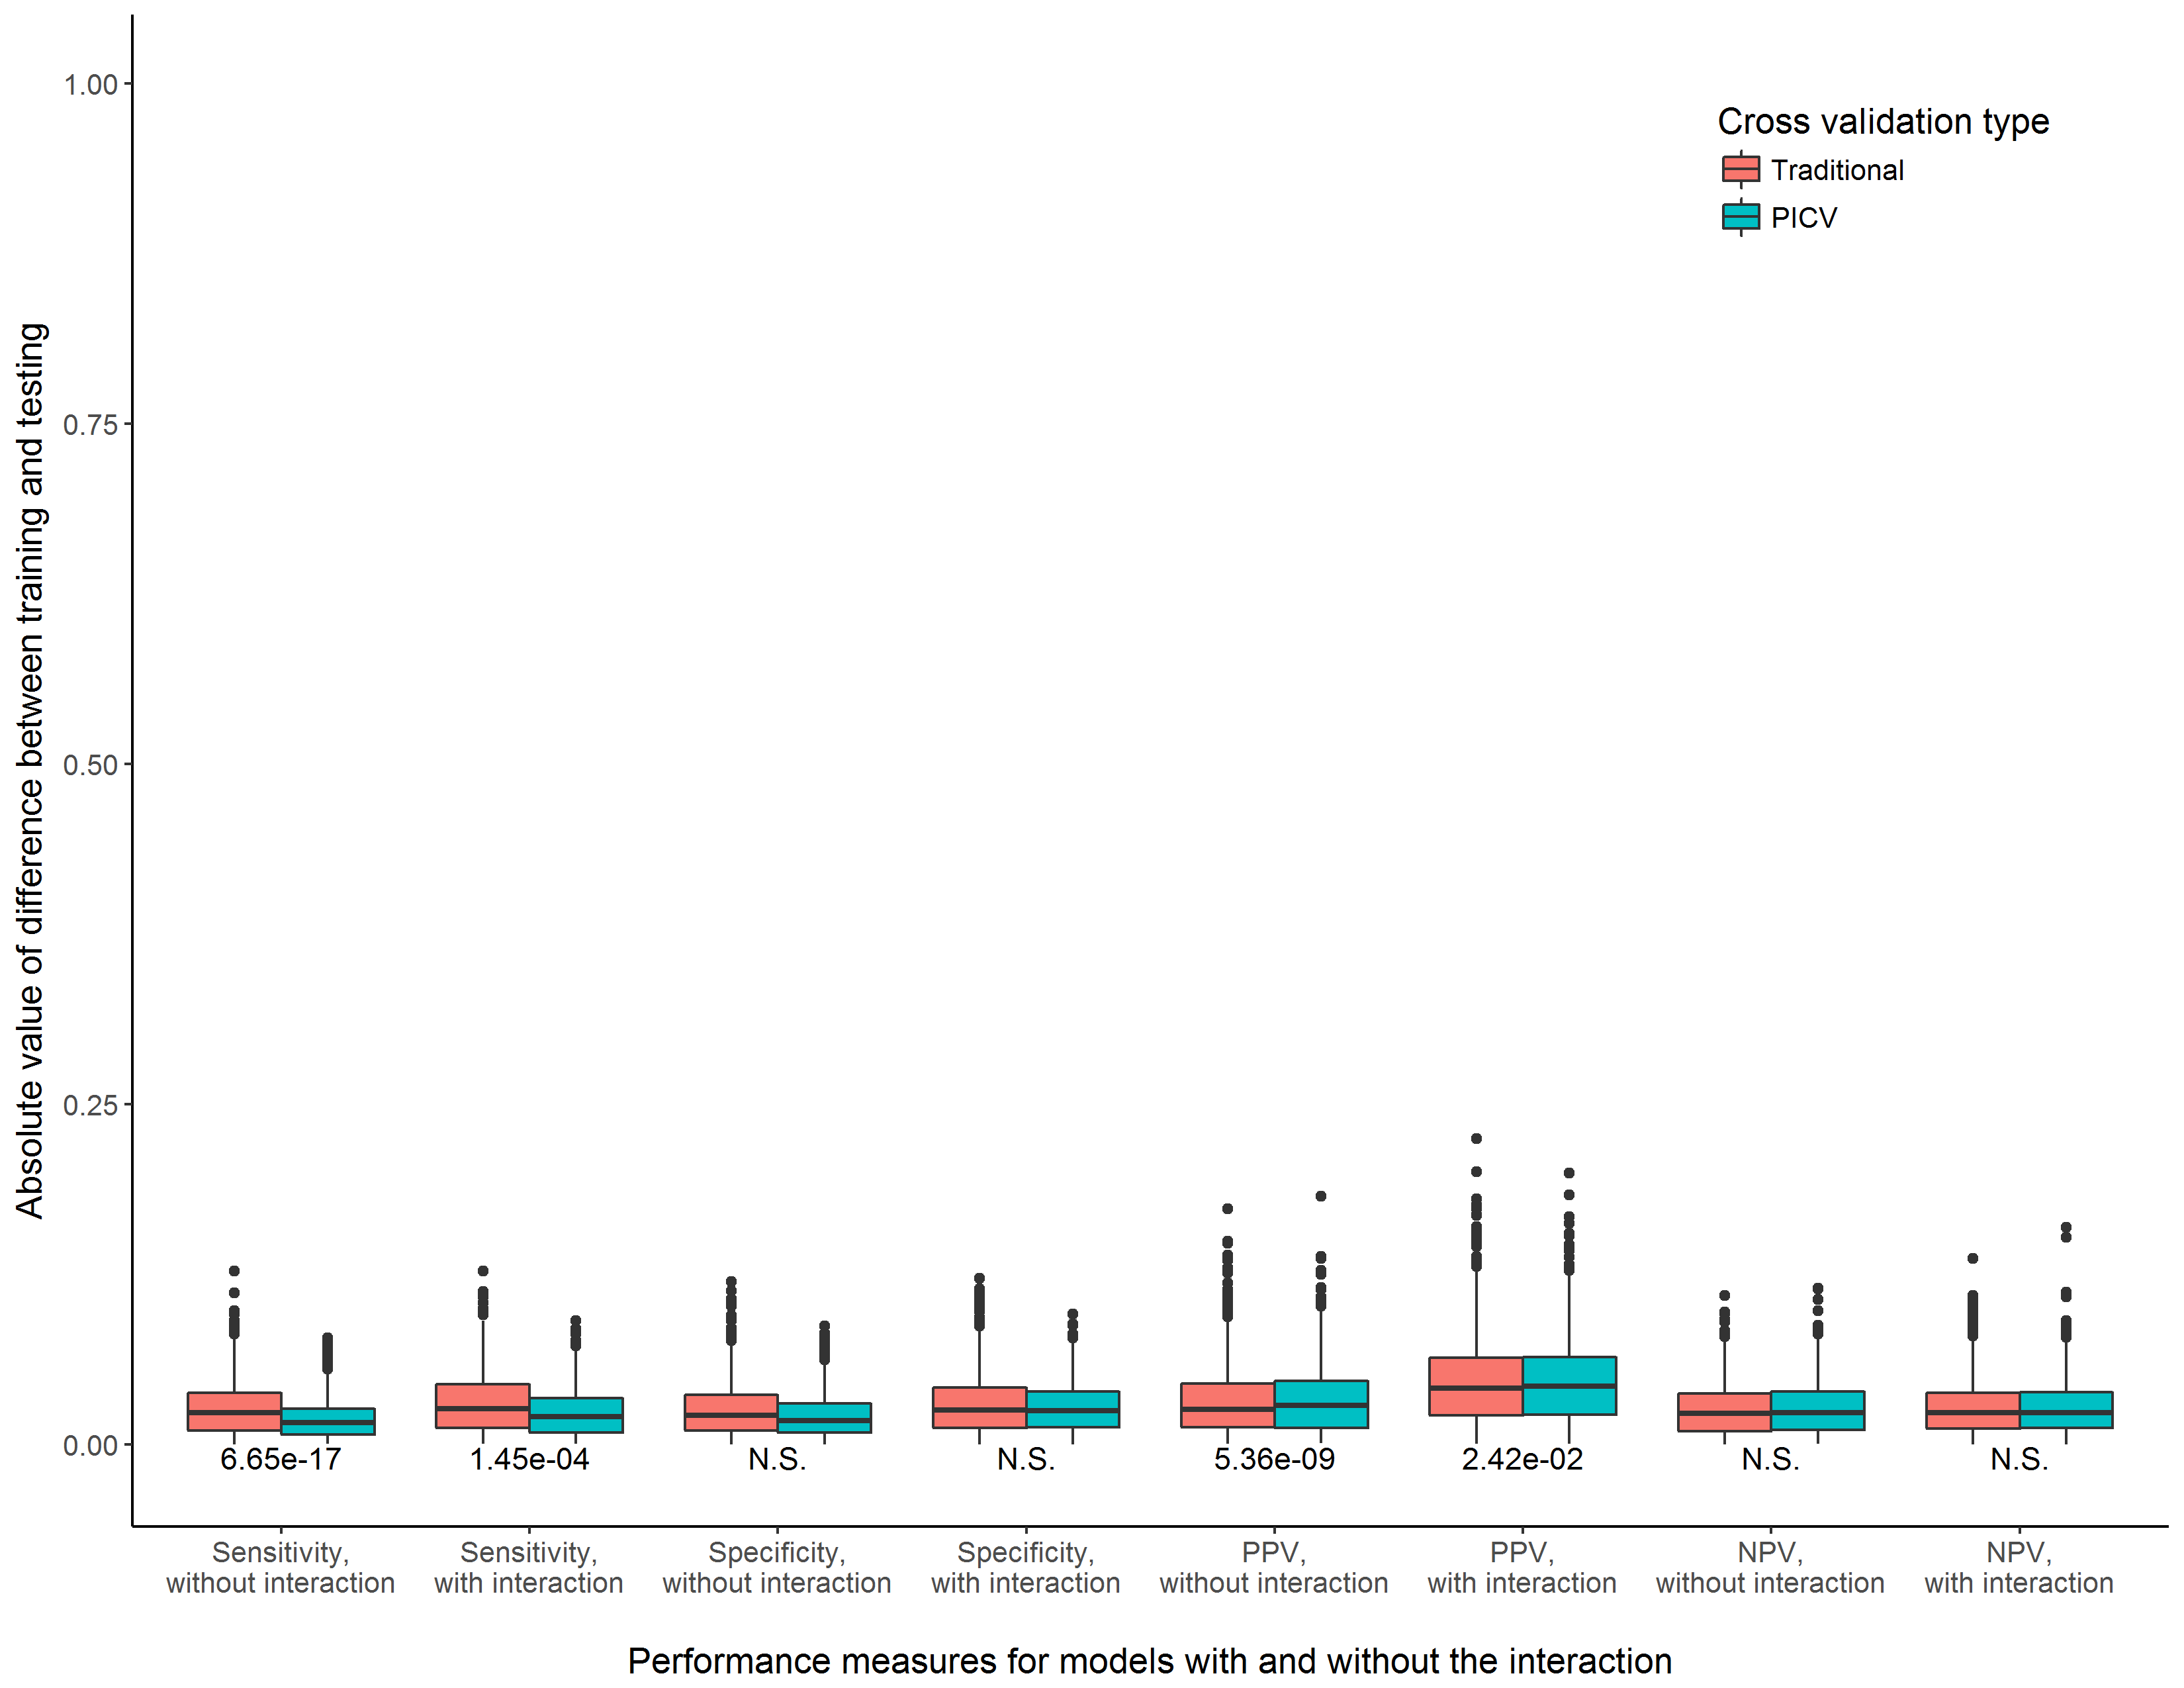

**Supplemental Figure 8.** Consistency of training and testing performance measures for models with and without the interaction term, comparing a traditional cross validation procedure to PICV. Experimental scenario 8, n = 2000

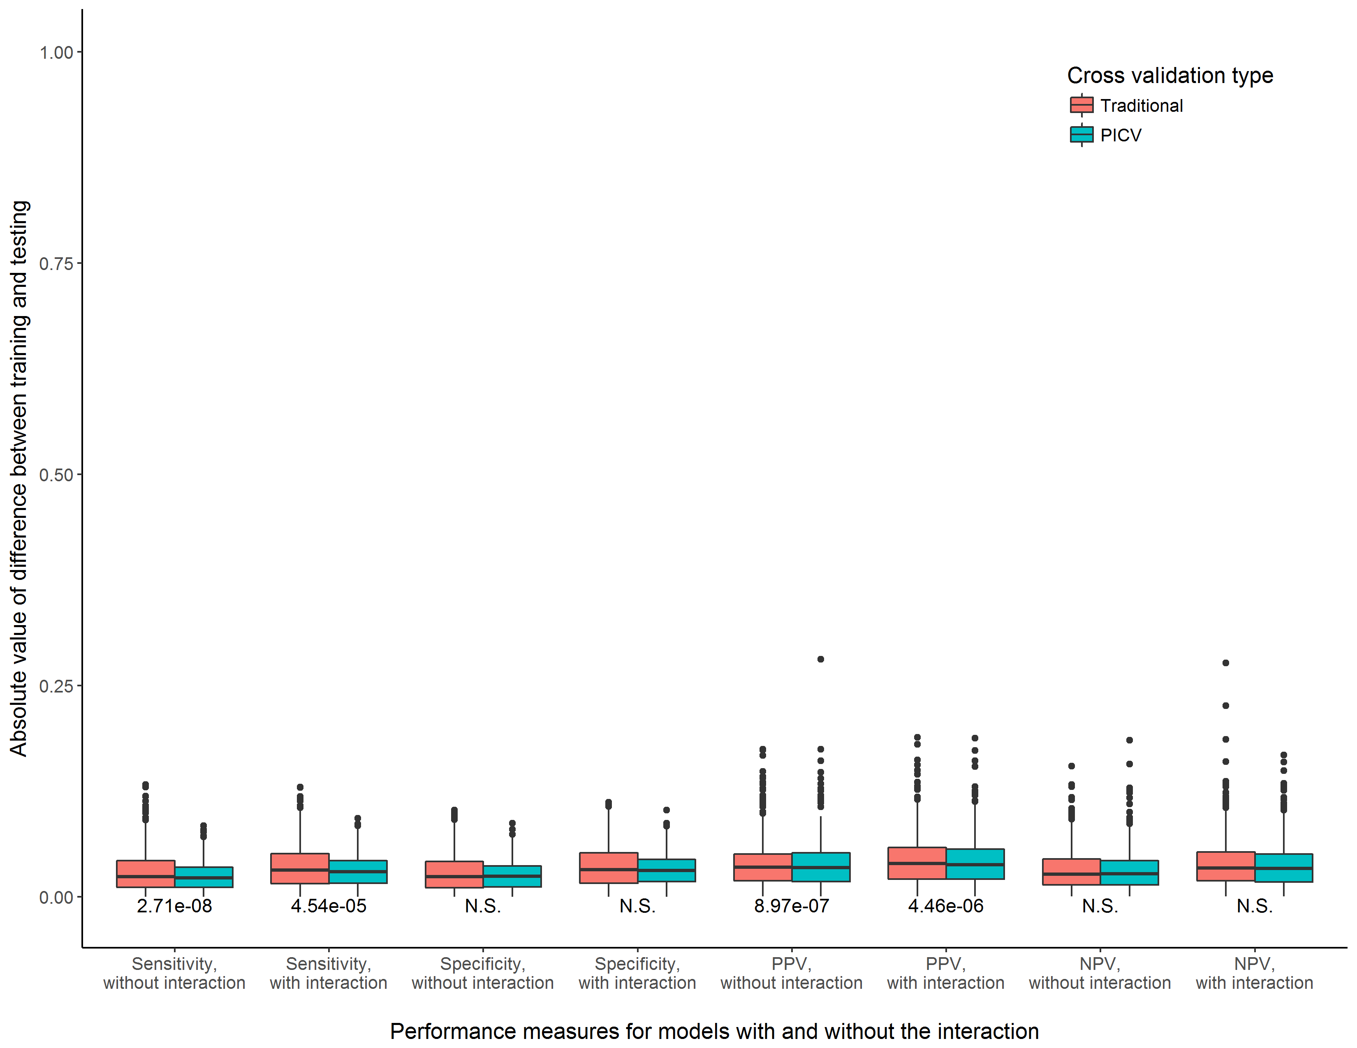

**Supplemental Figure 9.** Consistency of training and testing performance measures for models with and without the interaction term, comparing a traditional cross validation procedure to PICV. Experimental scenario 9, n = 2000

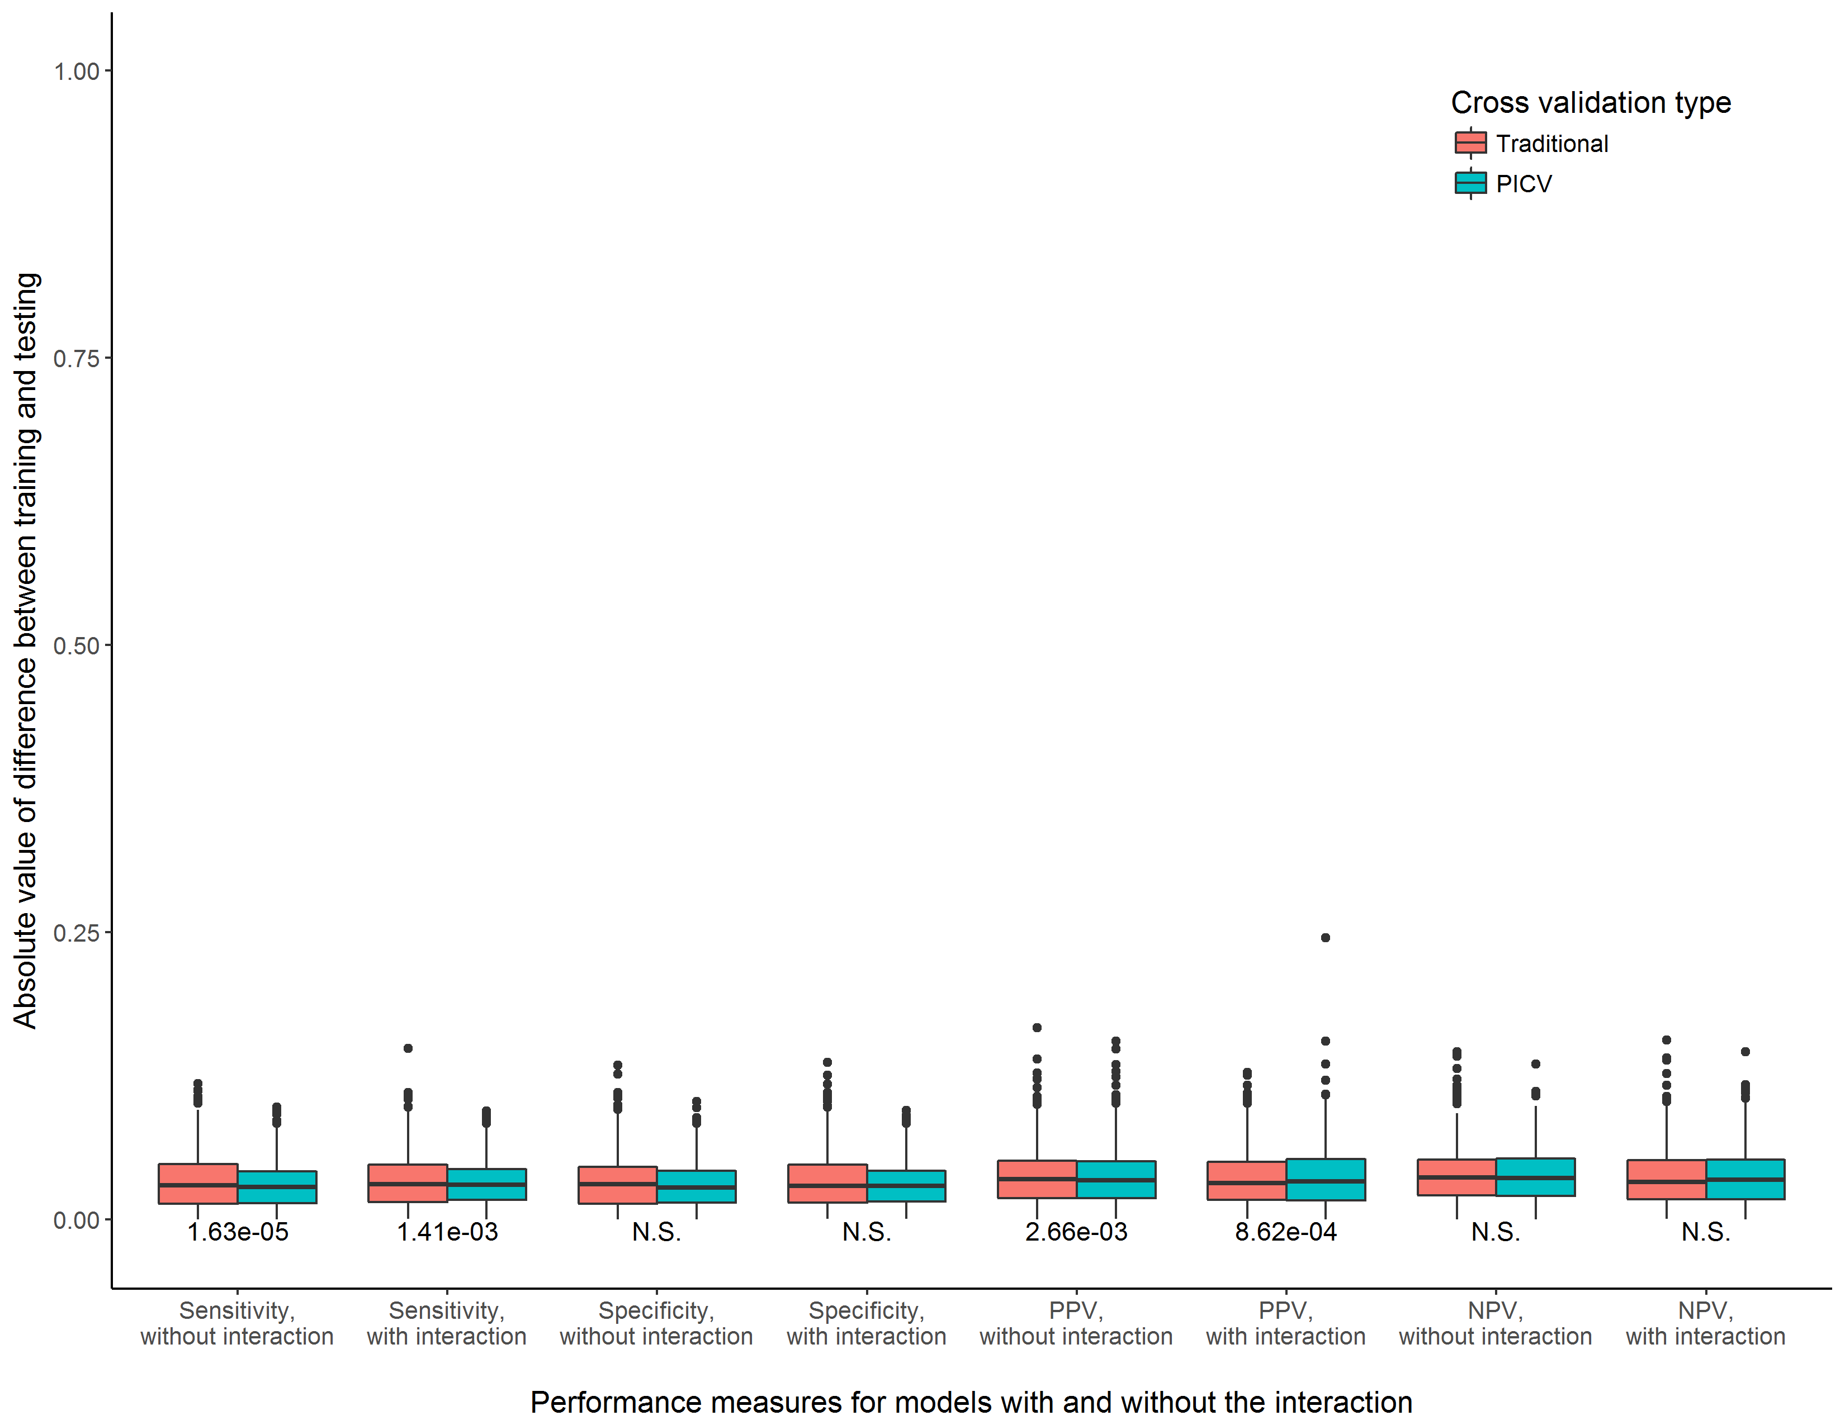

**Supplemental Figure 10.** Consistency of training and testing performance measures for models with and without the interaction term, comparing a traditional cross validation procedure to PICV. Experimental scenario 10, n = 2000

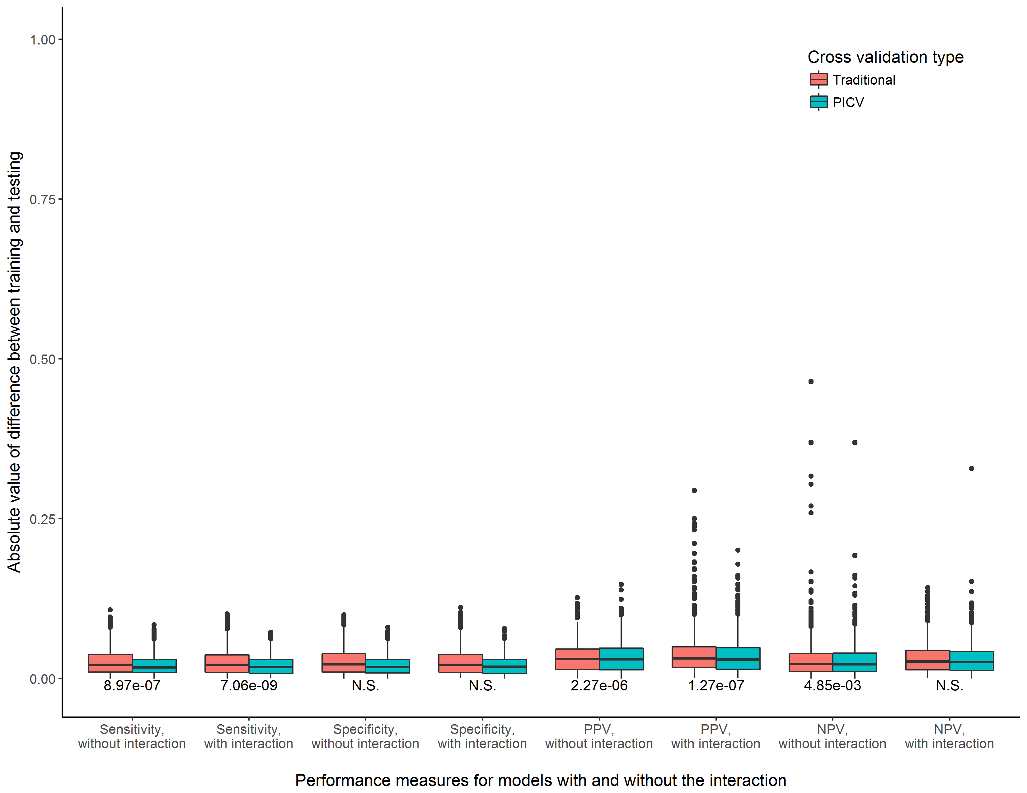

**Supplemental Figure 11.** Consistency of training and testing performance measures for models with and without the interaction term, comparing a traditional cross validation procedure to PICV. Experimental scenario 11, n = 2000

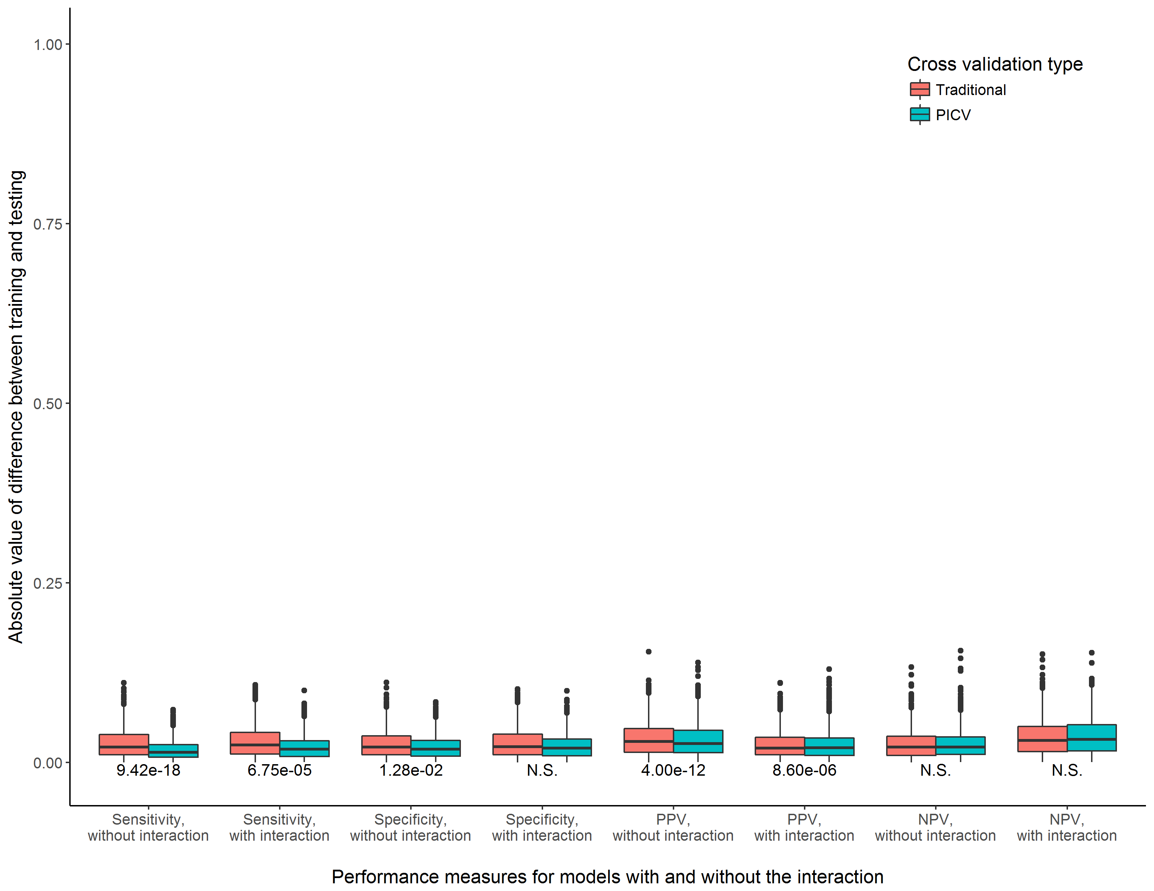

**Supplemental Figure 12.** Consistency of training and testing performance measures for models with and without the interaction term, comparing a traditional cross validation procedure to PICV. Experimental scenario 12, n = 2000

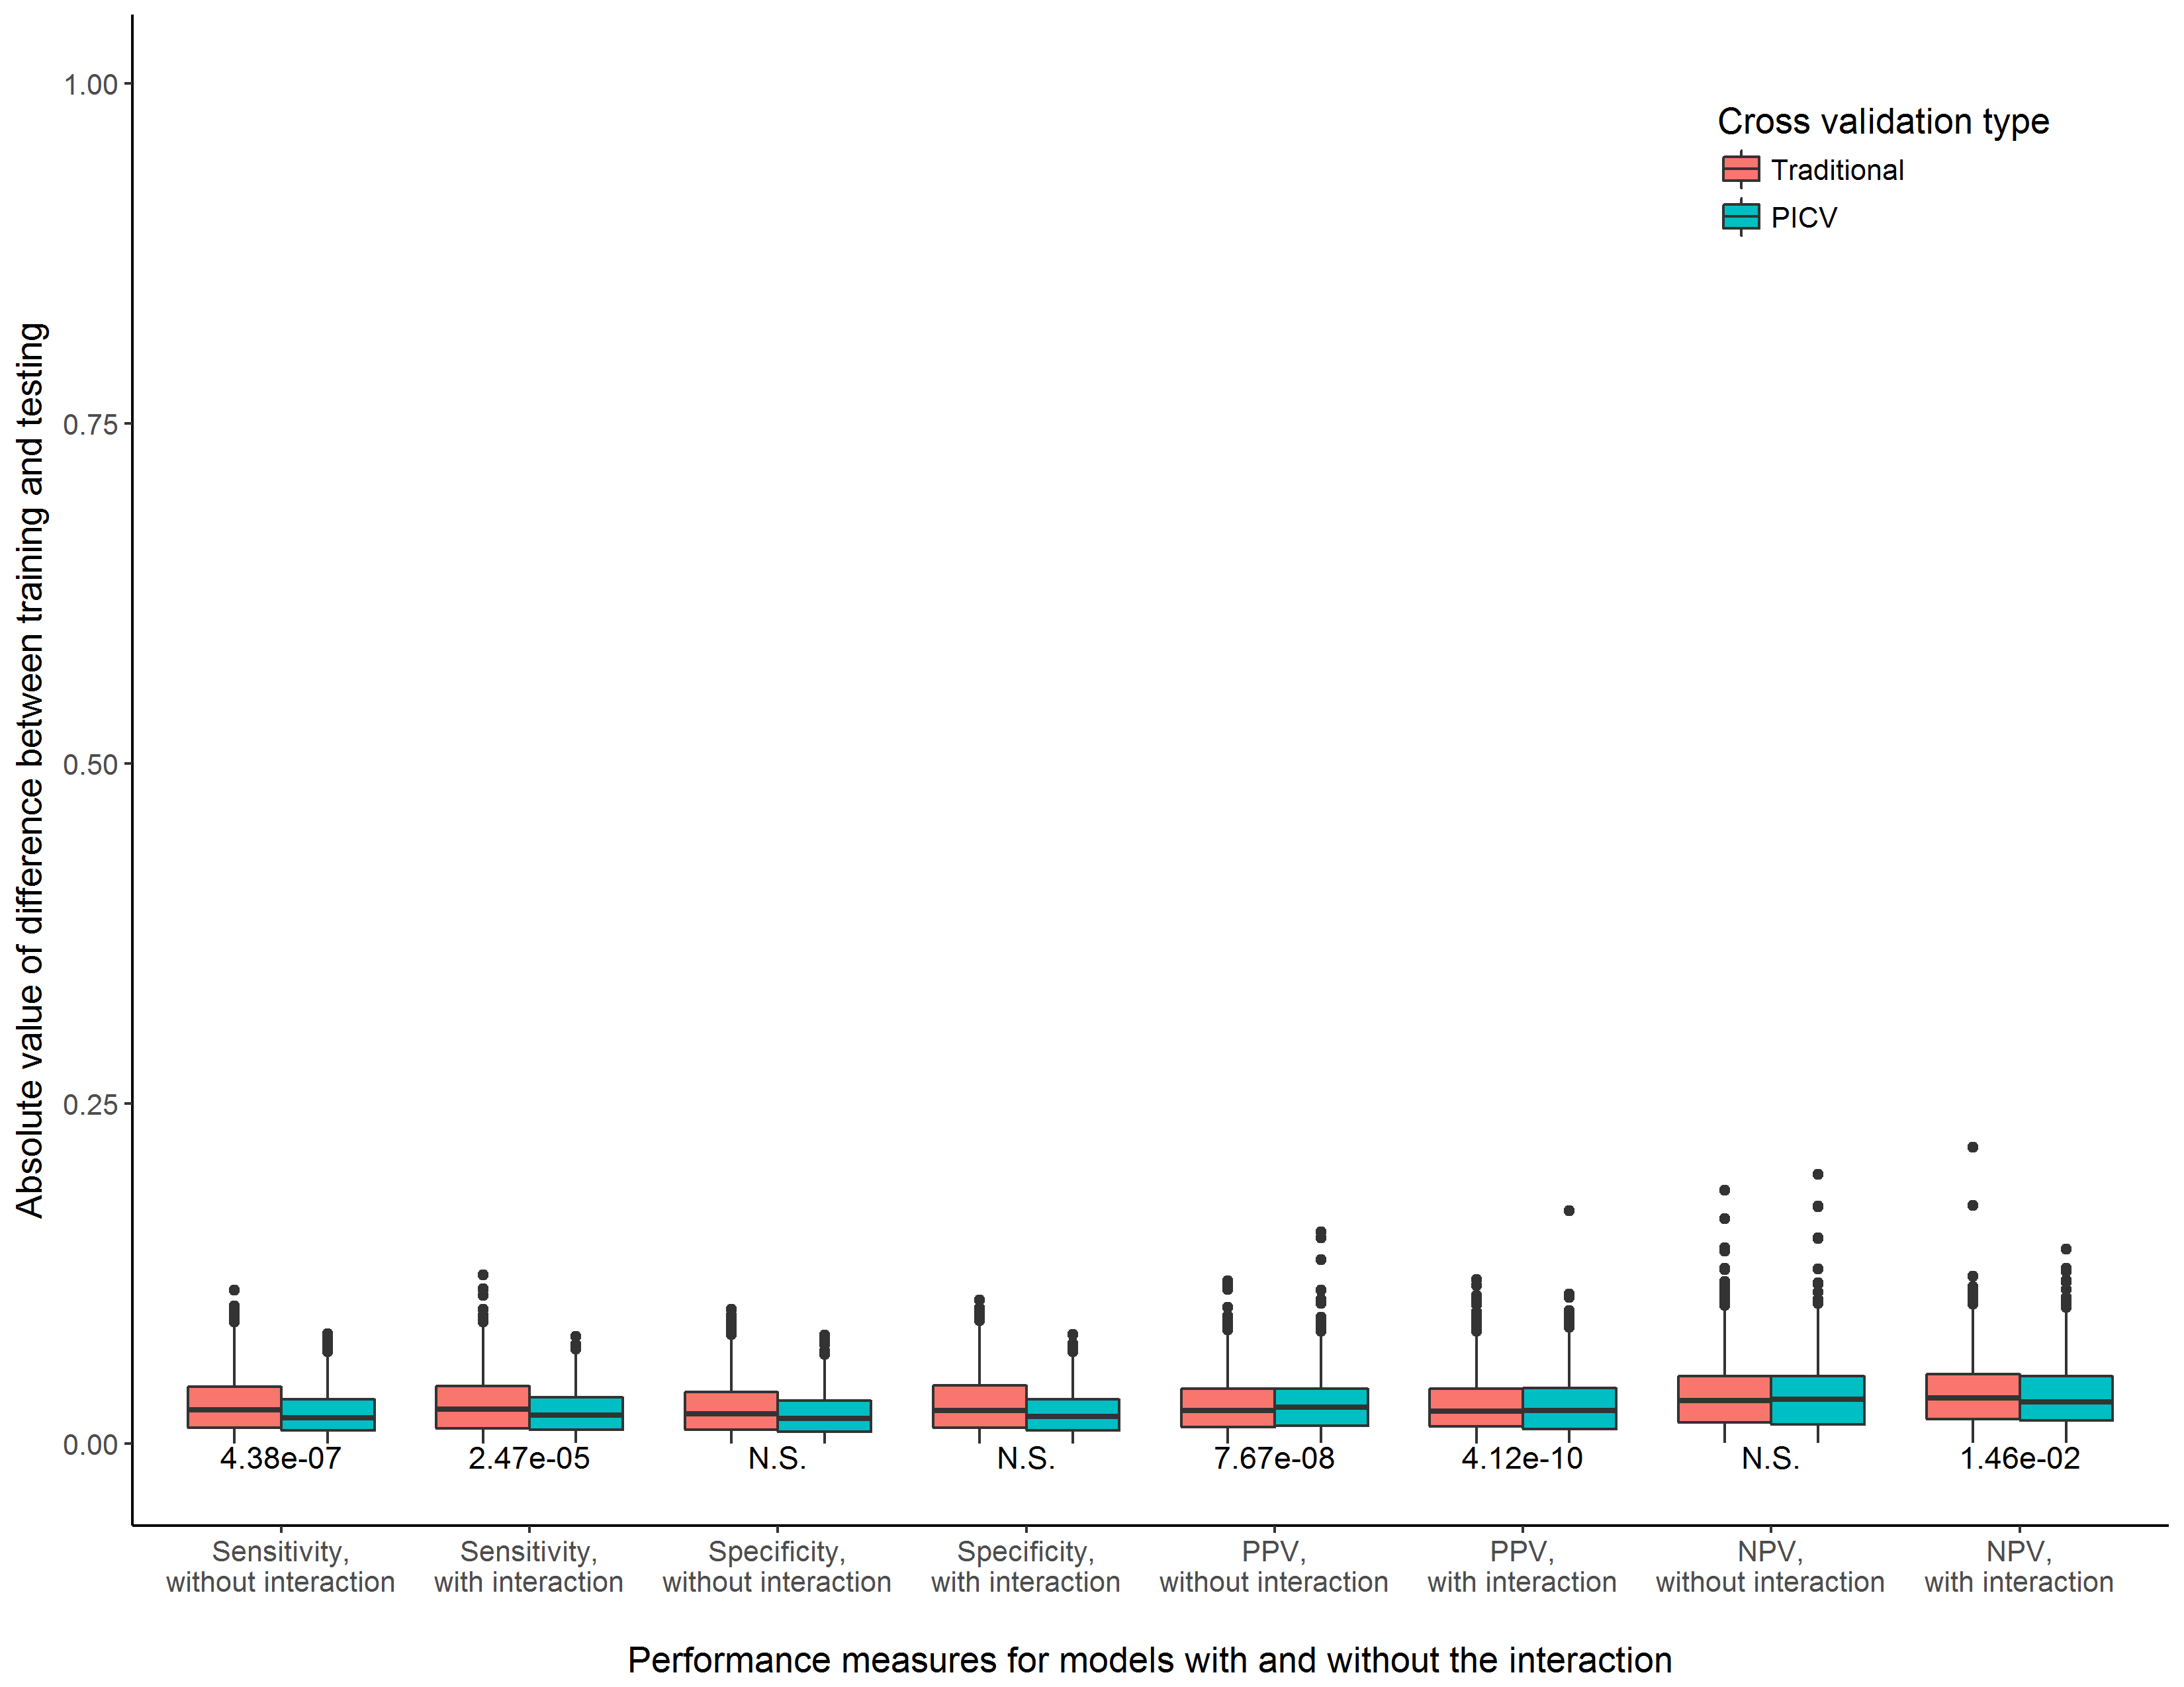

**Supplemental Figure 13.** Consistency of training and testing performance measures for models with and without the interaction term, comparing a traditional cross validation procedure to PICV. Experimental scenario 13, n = 2000

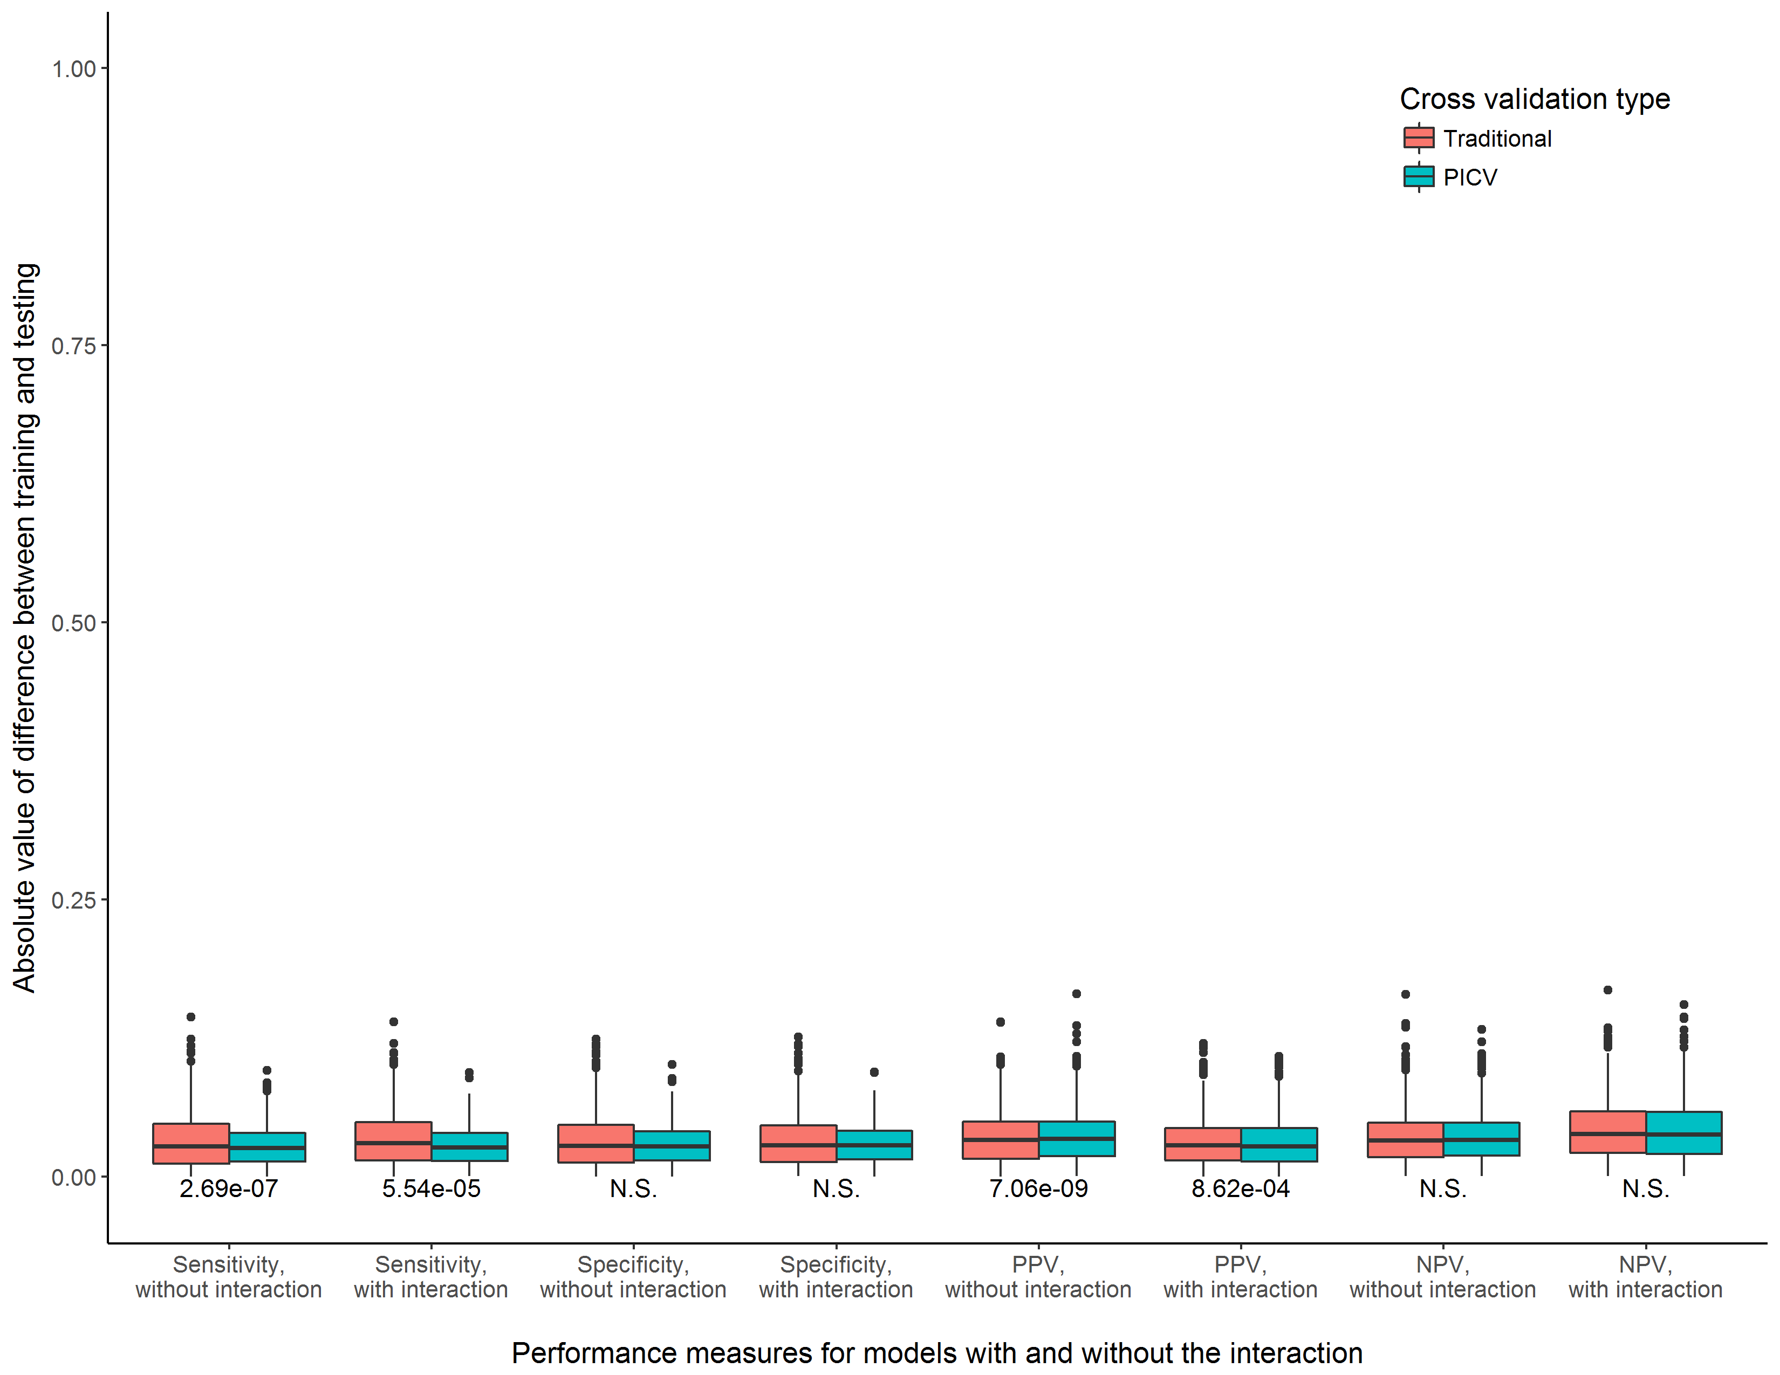

**Supplemental Figure 14.** Consistency of training and testing performance measures for models with and without the interaction term, comparing a traditional cross validation procedure to PICV. Experimental scenario 14, n = 2000

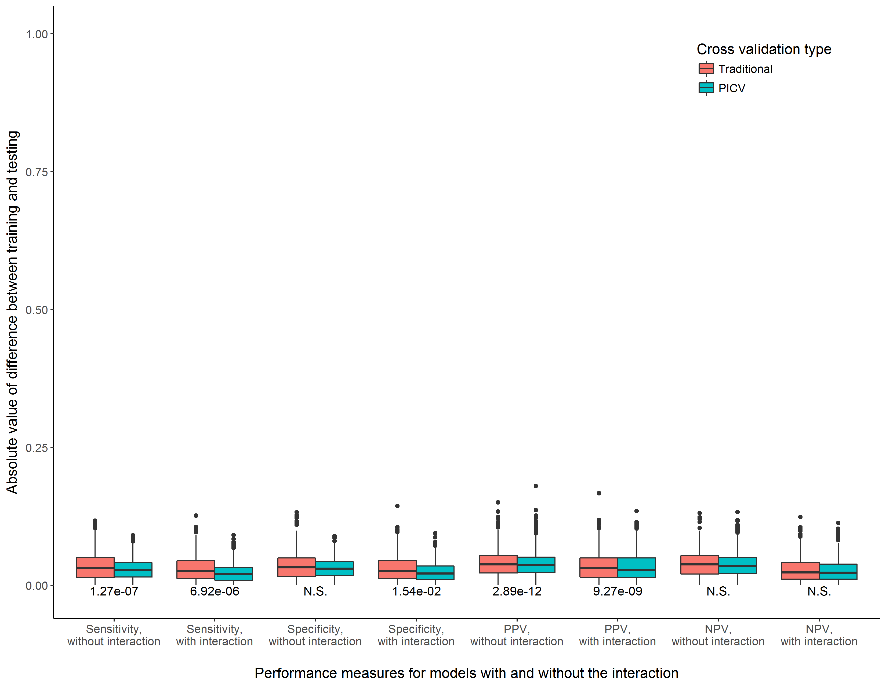

**Supplemental Figure 15.** Consistency of training and testing performance measures for models with and without the interaction term, comparing a traditional cross validation procedure to PICV. Experimental scenario 15, n = 2000

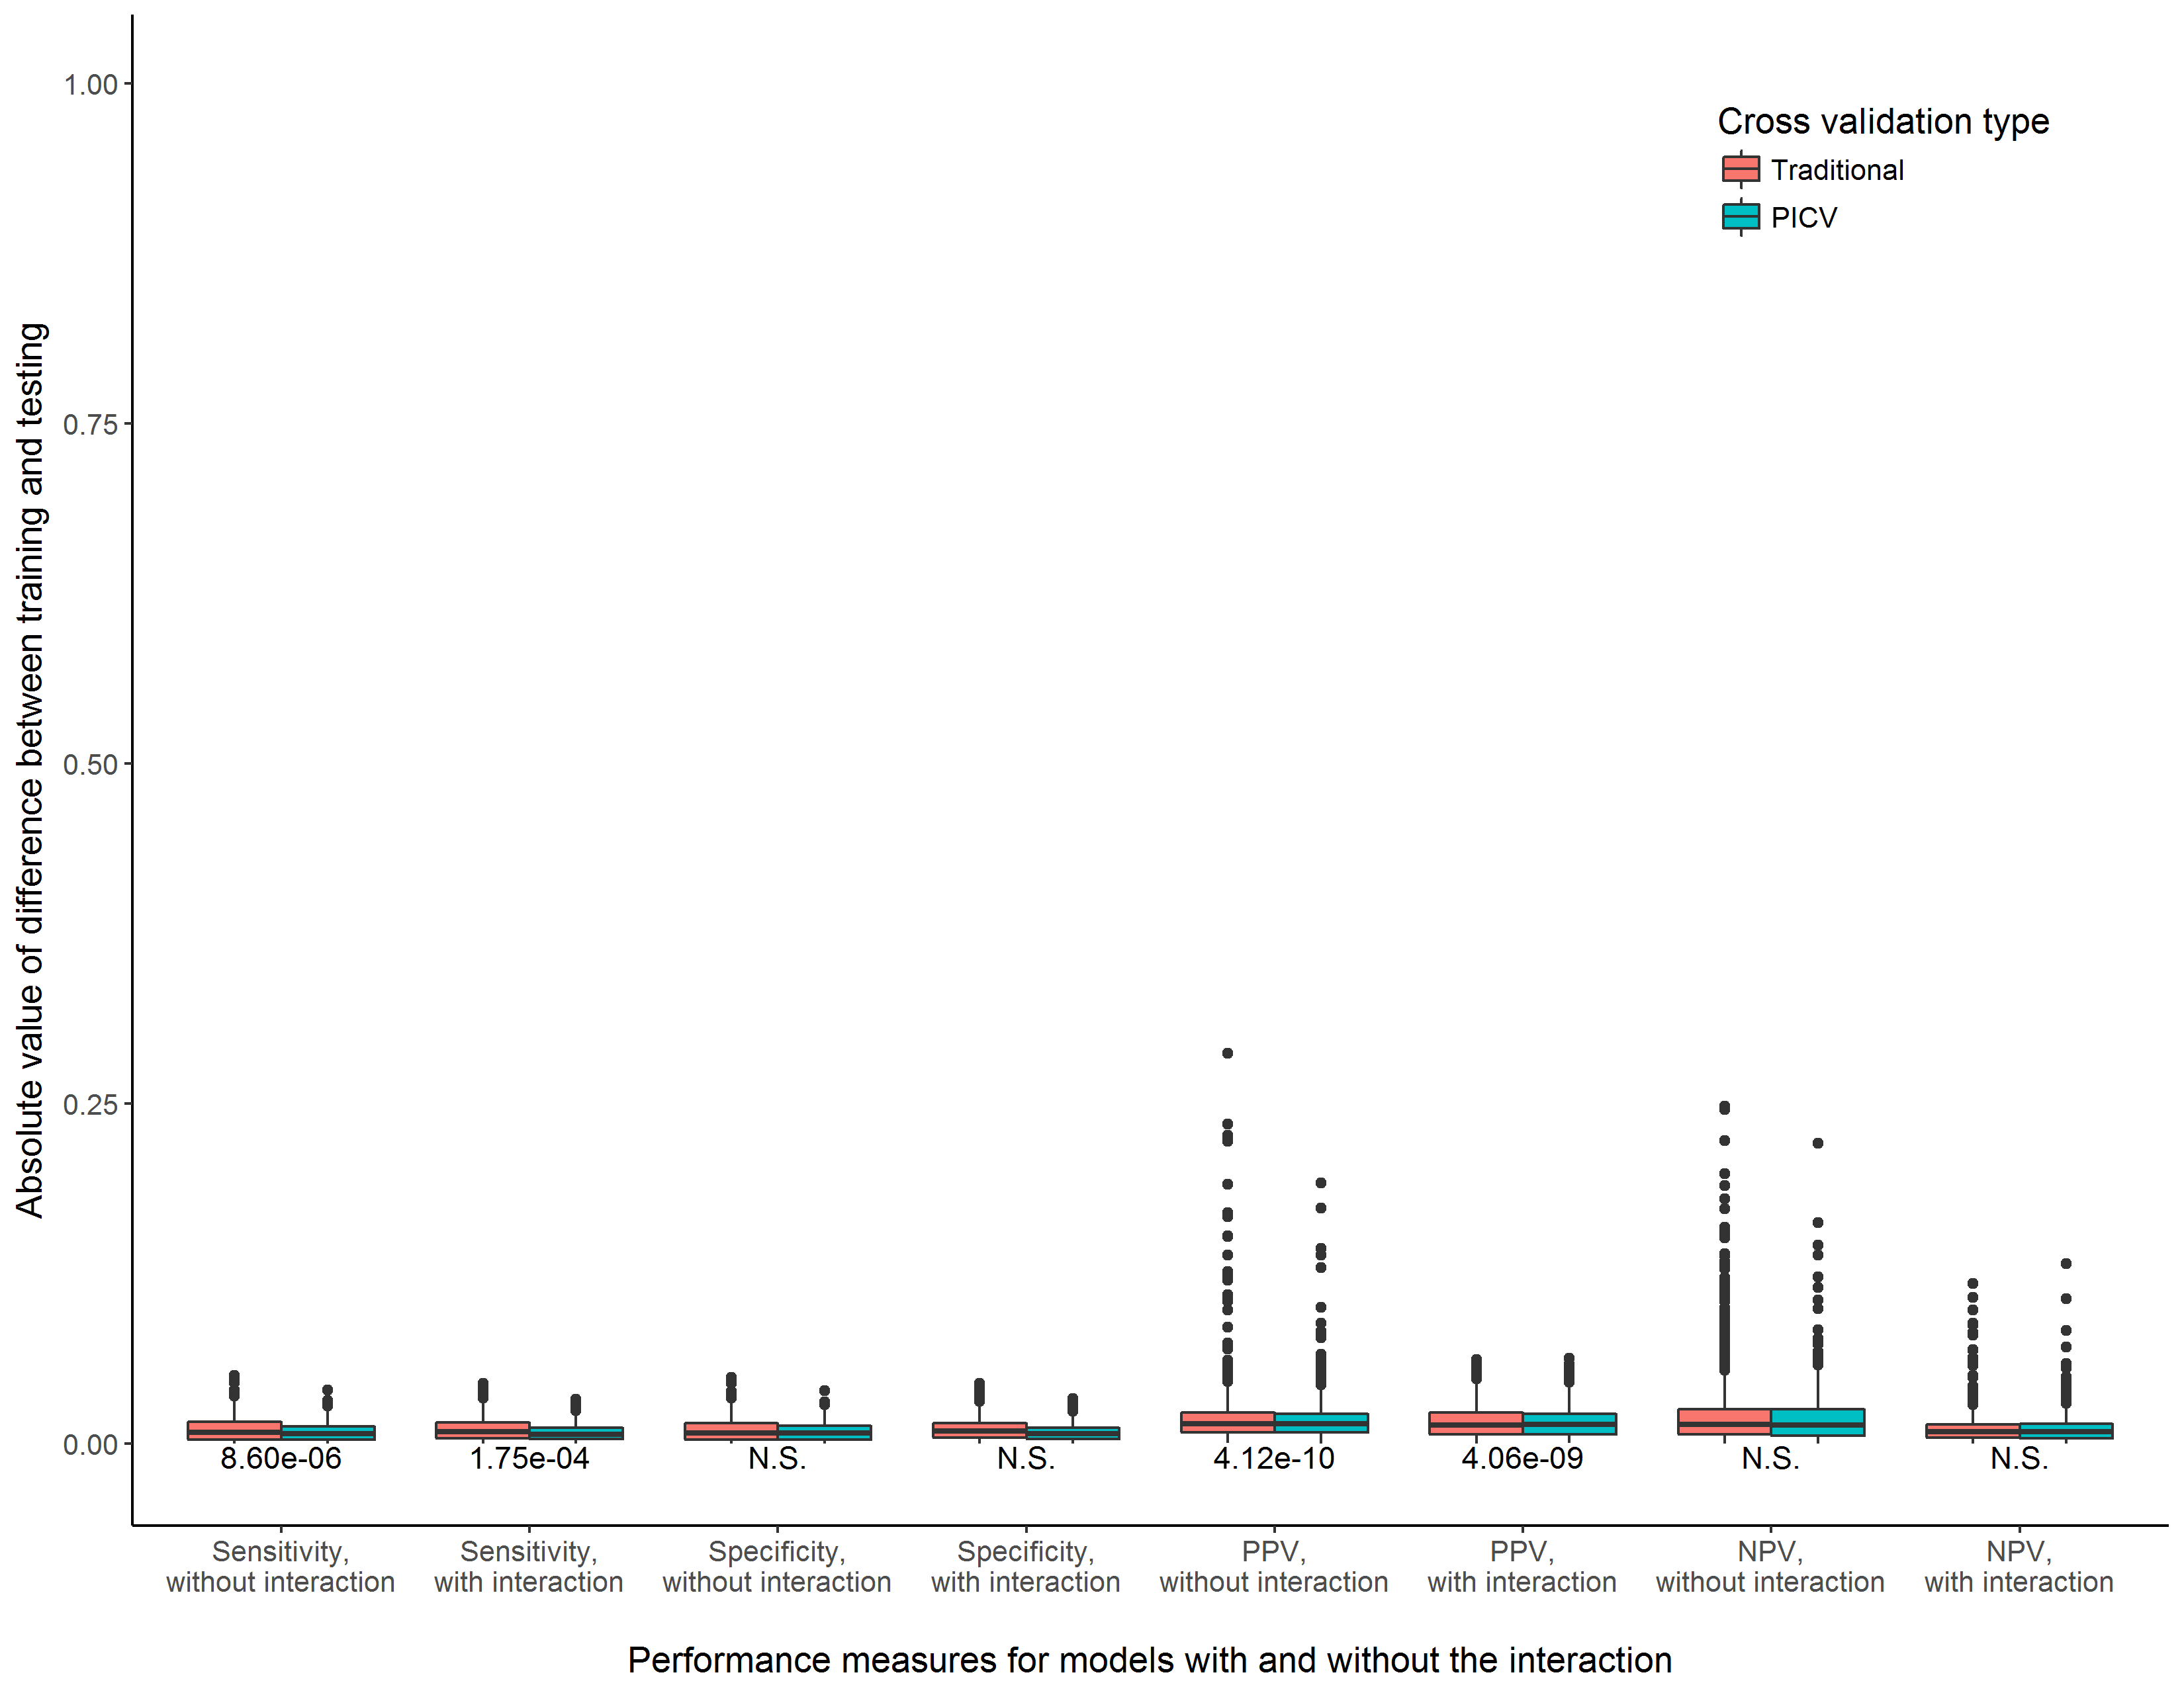

**Supplemental Figure 16.** Consistency of training and testing performance measures for models with and without the interaction term, comparing a traditional cross validation procedure to PICV. Experimental scenario 1, n = 10000

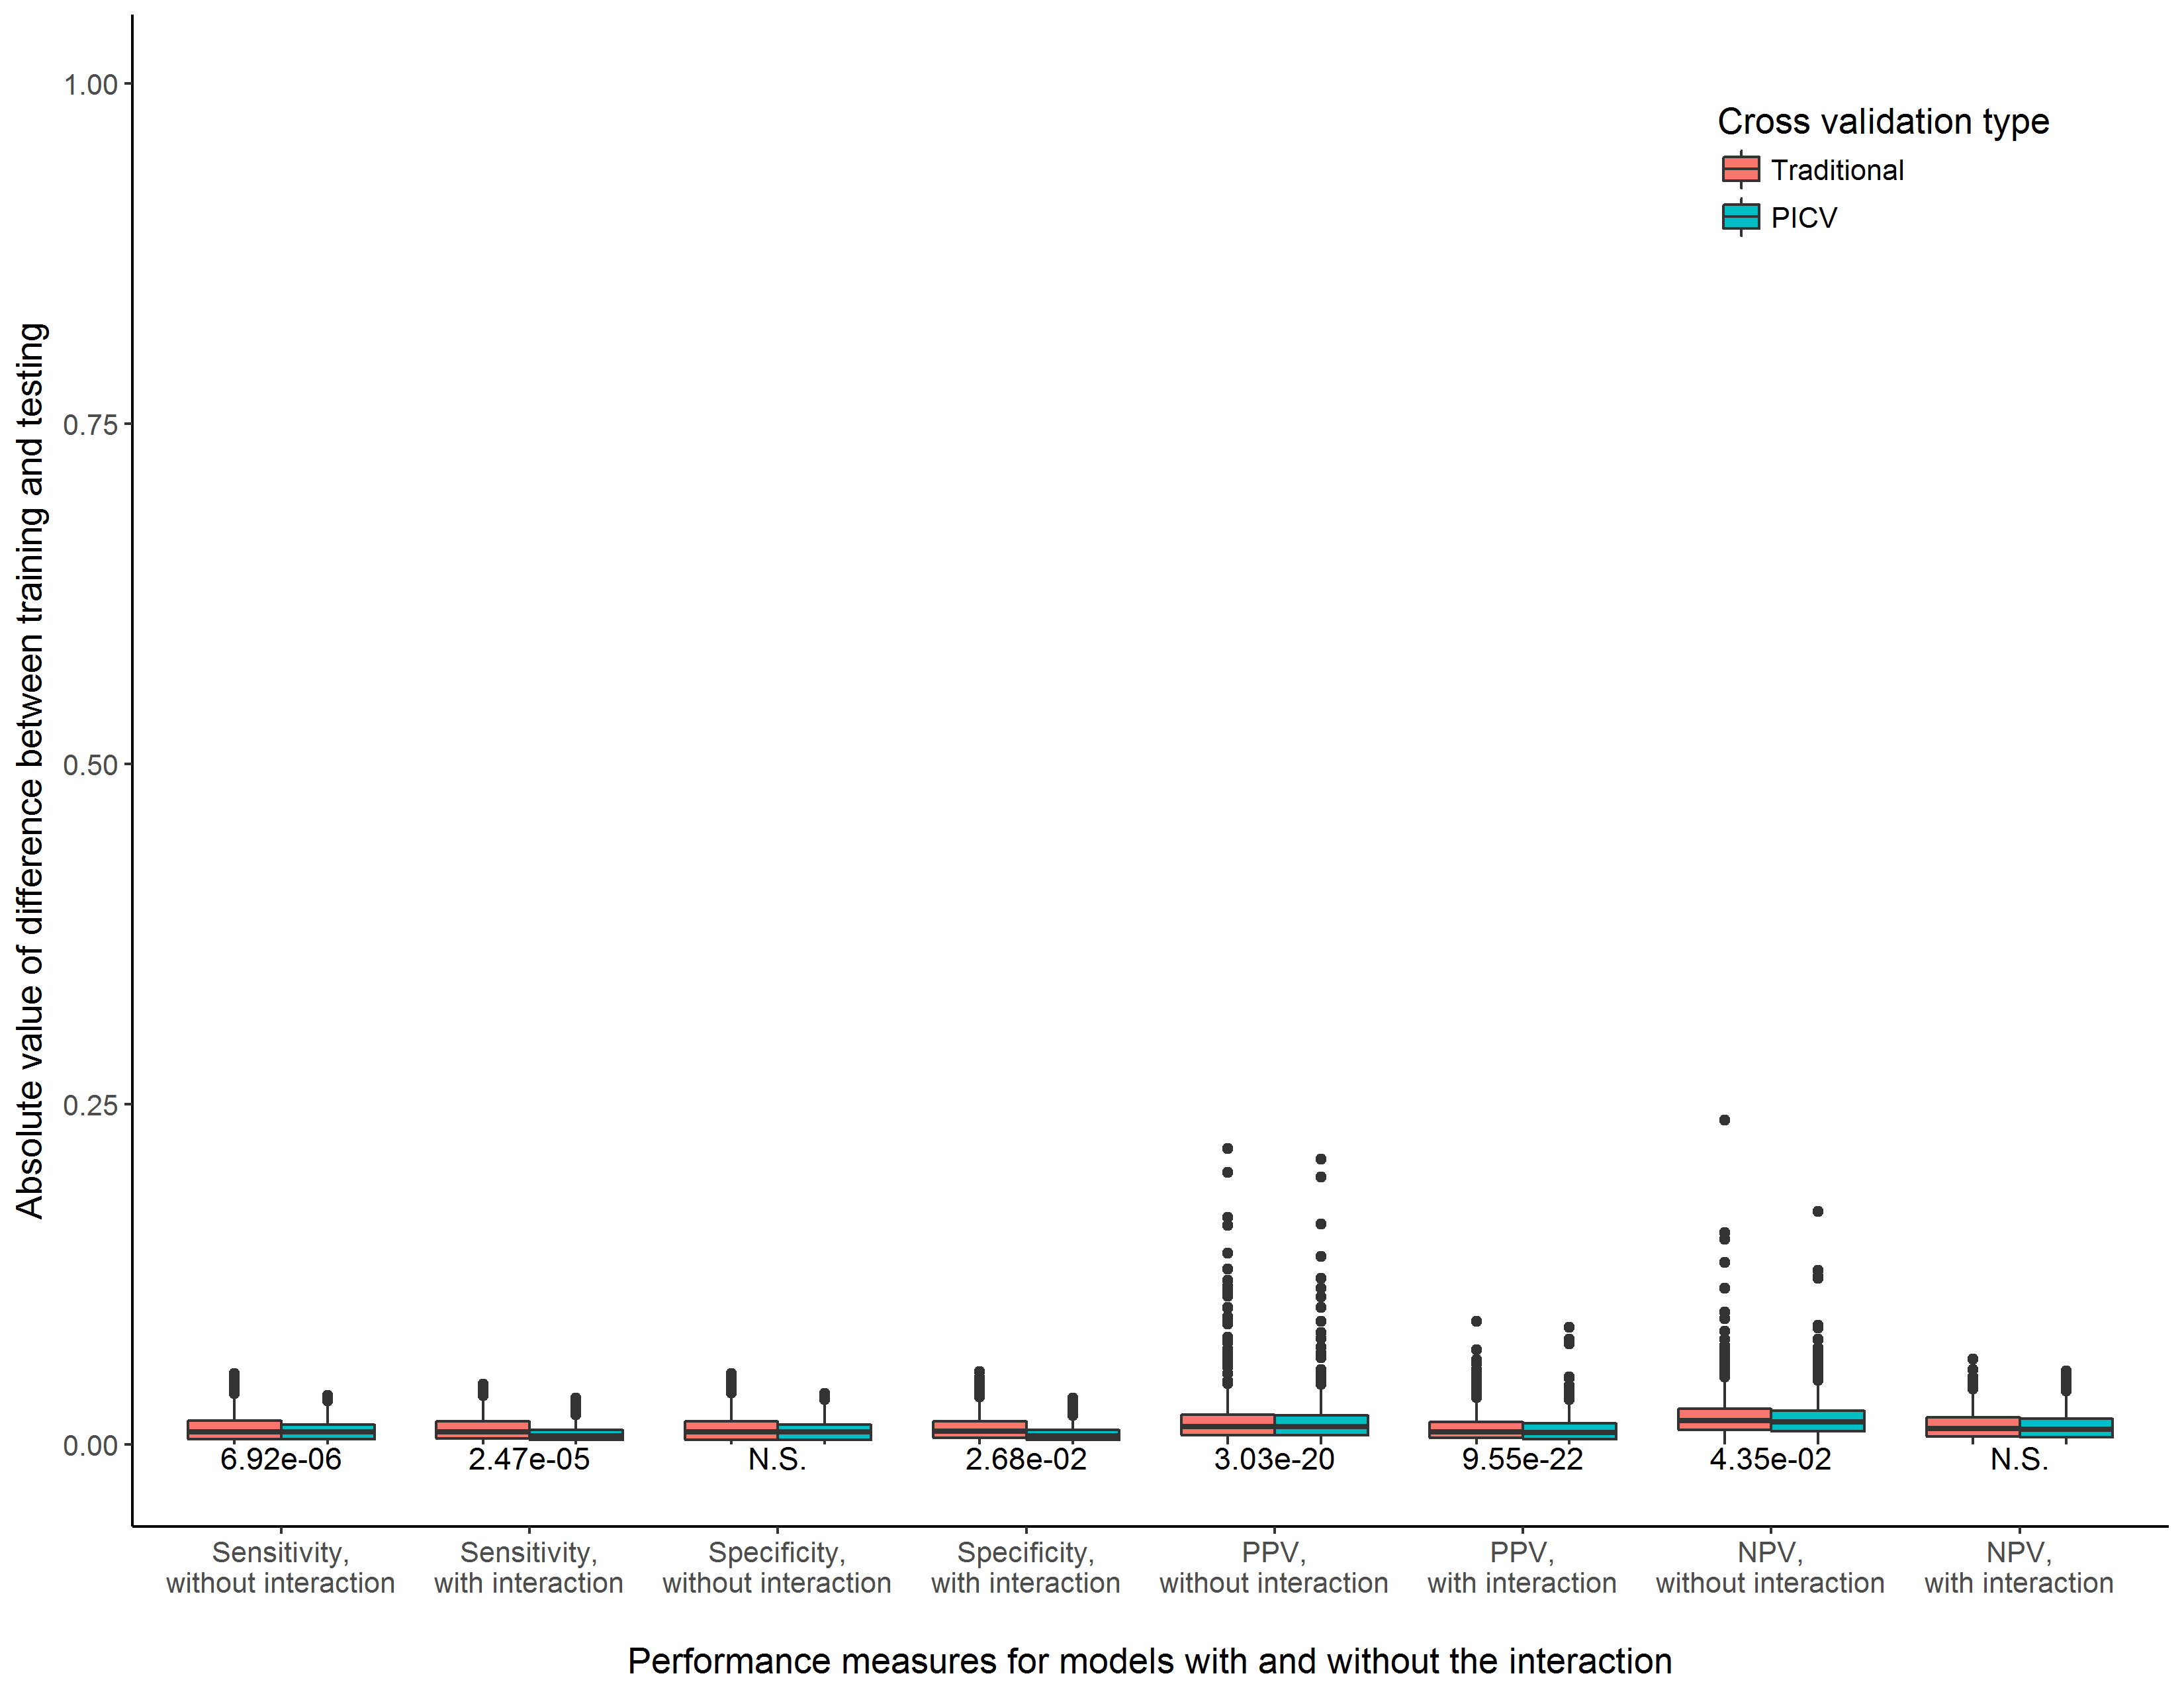

**Supplemental Figure 17.** Consistency of training and testing performance measures for models with and without the interaction term, comparing a traditional cross validation procedure to PICV. Experimental scenario 2, n = 10000

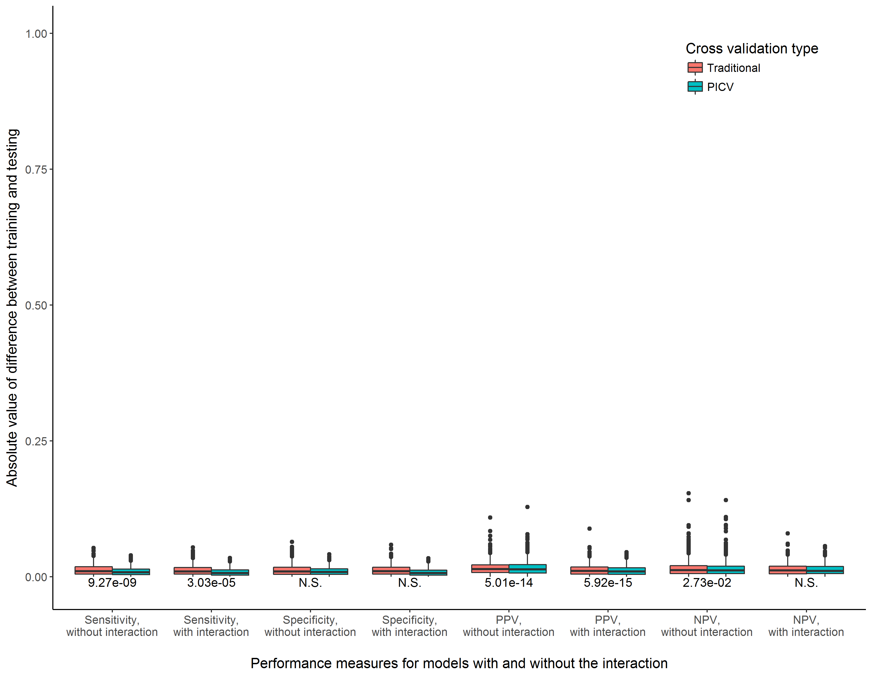

**Supplemental Figure 18.** Consistency of training and testing performance measures for models with and without the interaction term, comparing a traditional cross validation procedure to PICV. Experimental scenario 3, n = 10000

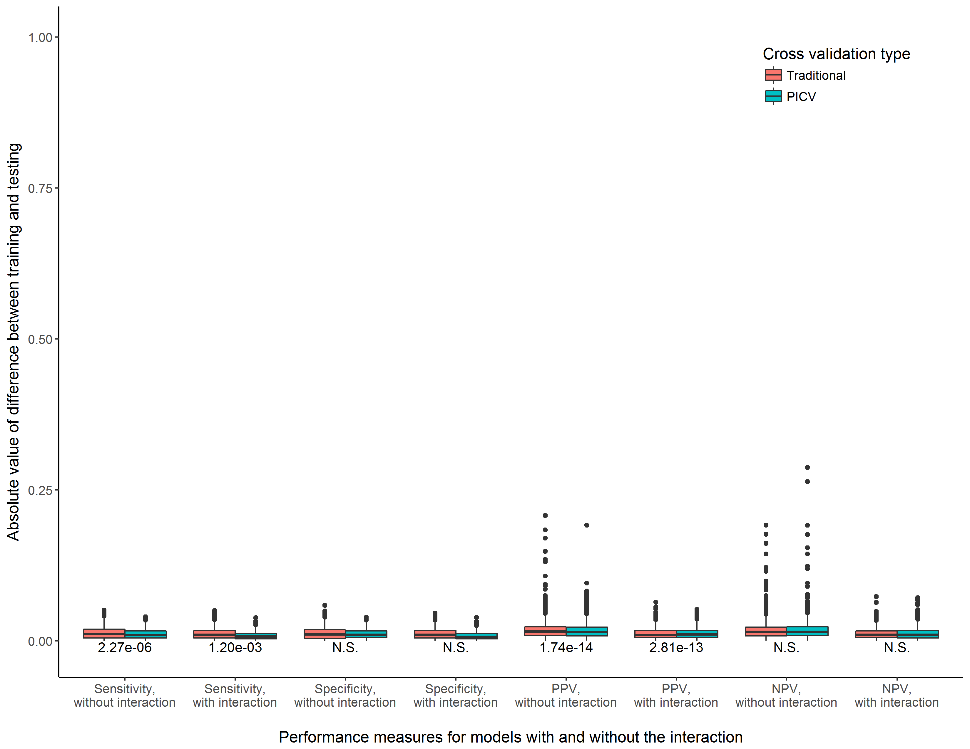

**Supplemental Figure 19.** Consistency of training and testing performance measures for models with and without the interaction term, comparing a traditional cross validation procedure to PICV. Experimental scenario 4, n = 10000

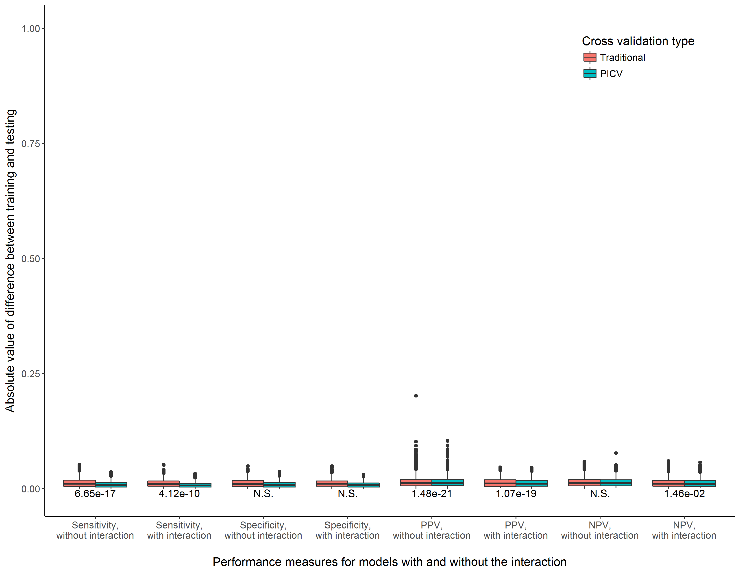

**Supplemental Figure 20.** Consistency of training and testing performance measures for models with and without the interaction term, comparing a traditional cross validation procedure to PICV. Experimental scenario 5, n = 10000

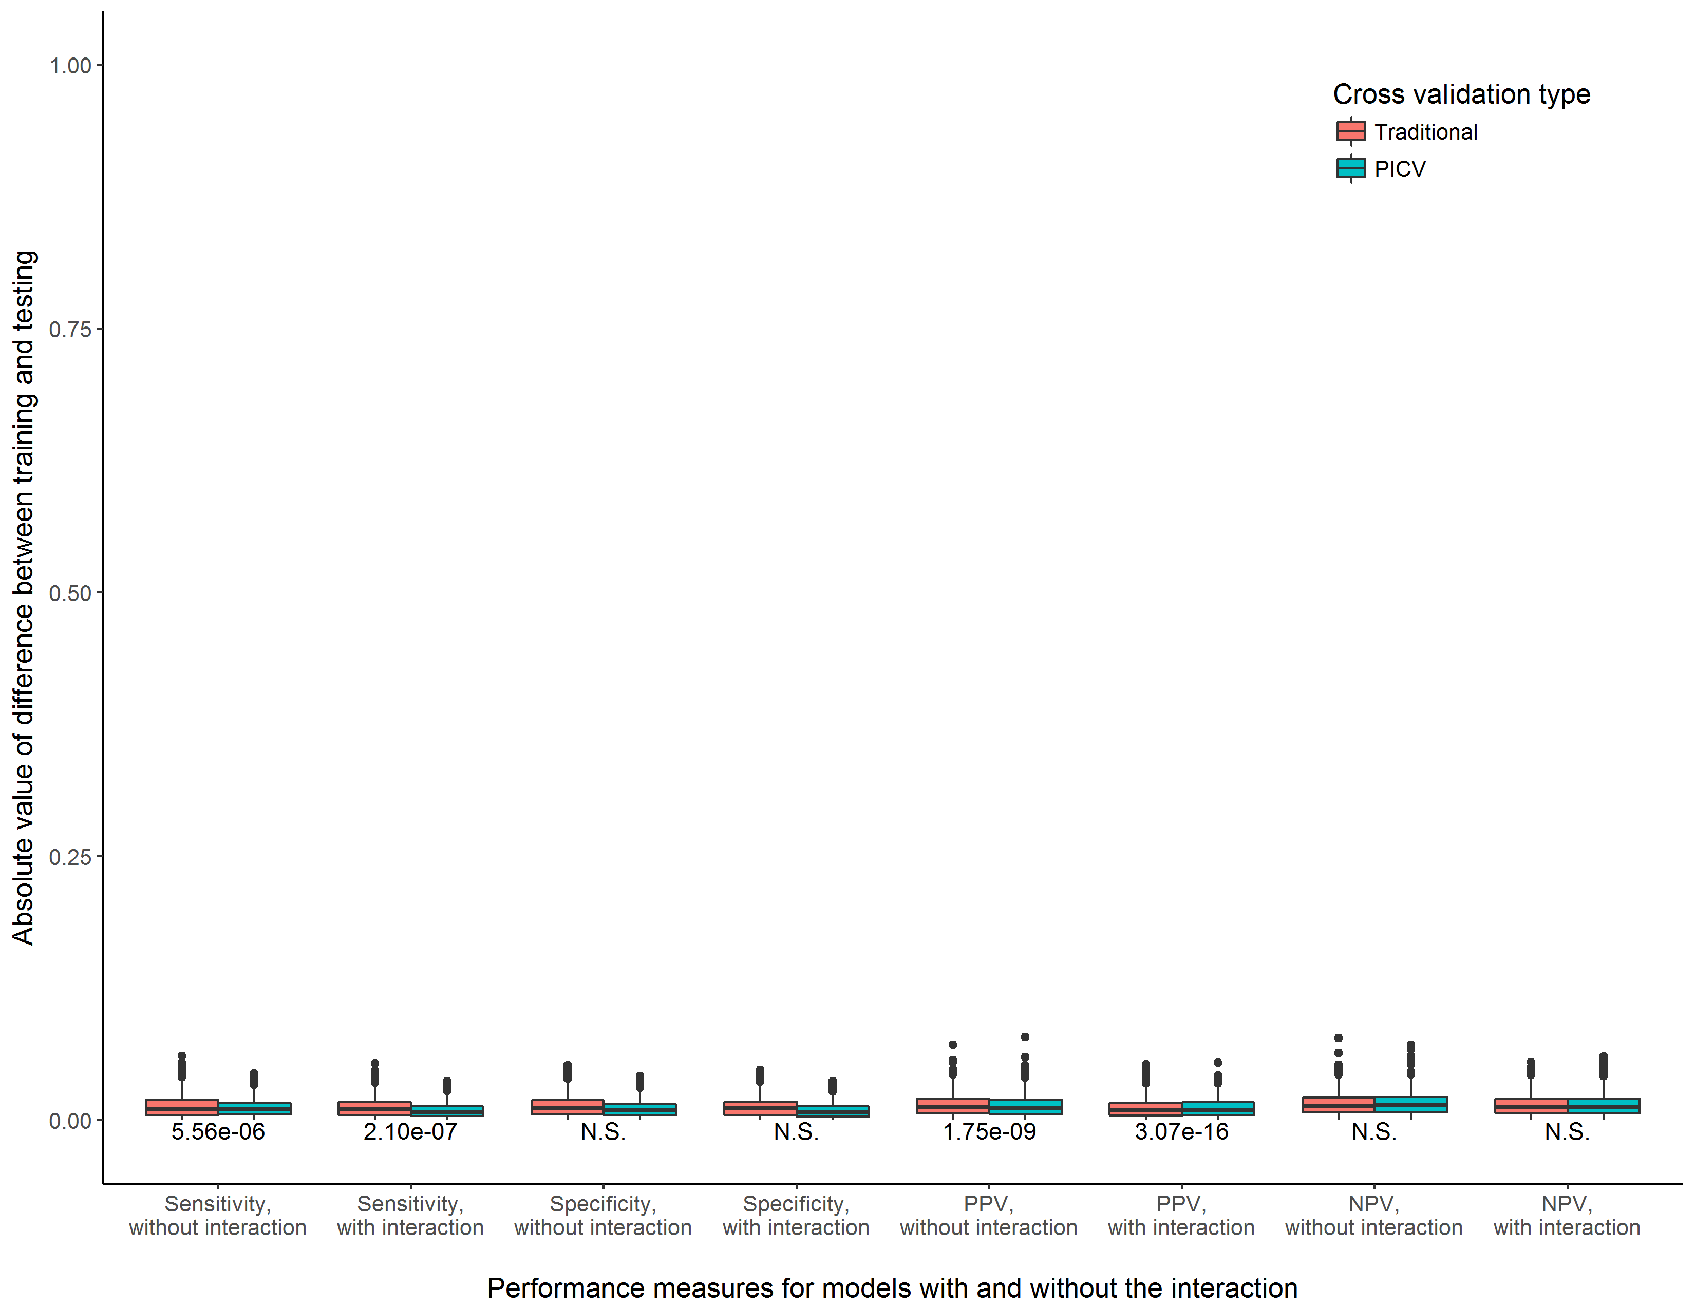

**Supplemental Figure 21.** Consistency of training and testing performance measures for models with and without the interaction term, comparing a traditional cross validation procedure to PICV. Experimental scenario 6, n = 10000

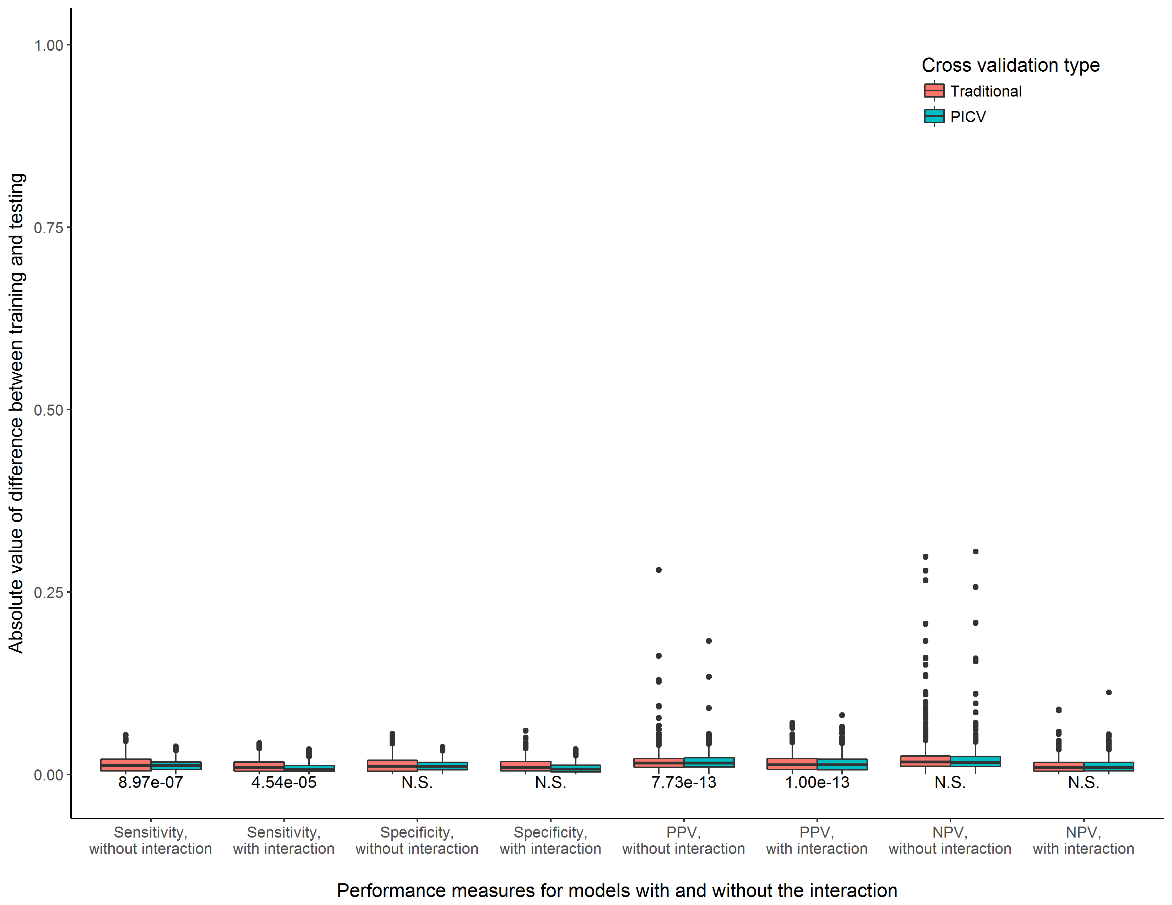

**Supplemental Figure 22.** Consistency of training and testing performance measures for models with and without the interaction term, comparing a traditional cross validation procedure to PICV. Experimental scenario 7, n = 10000

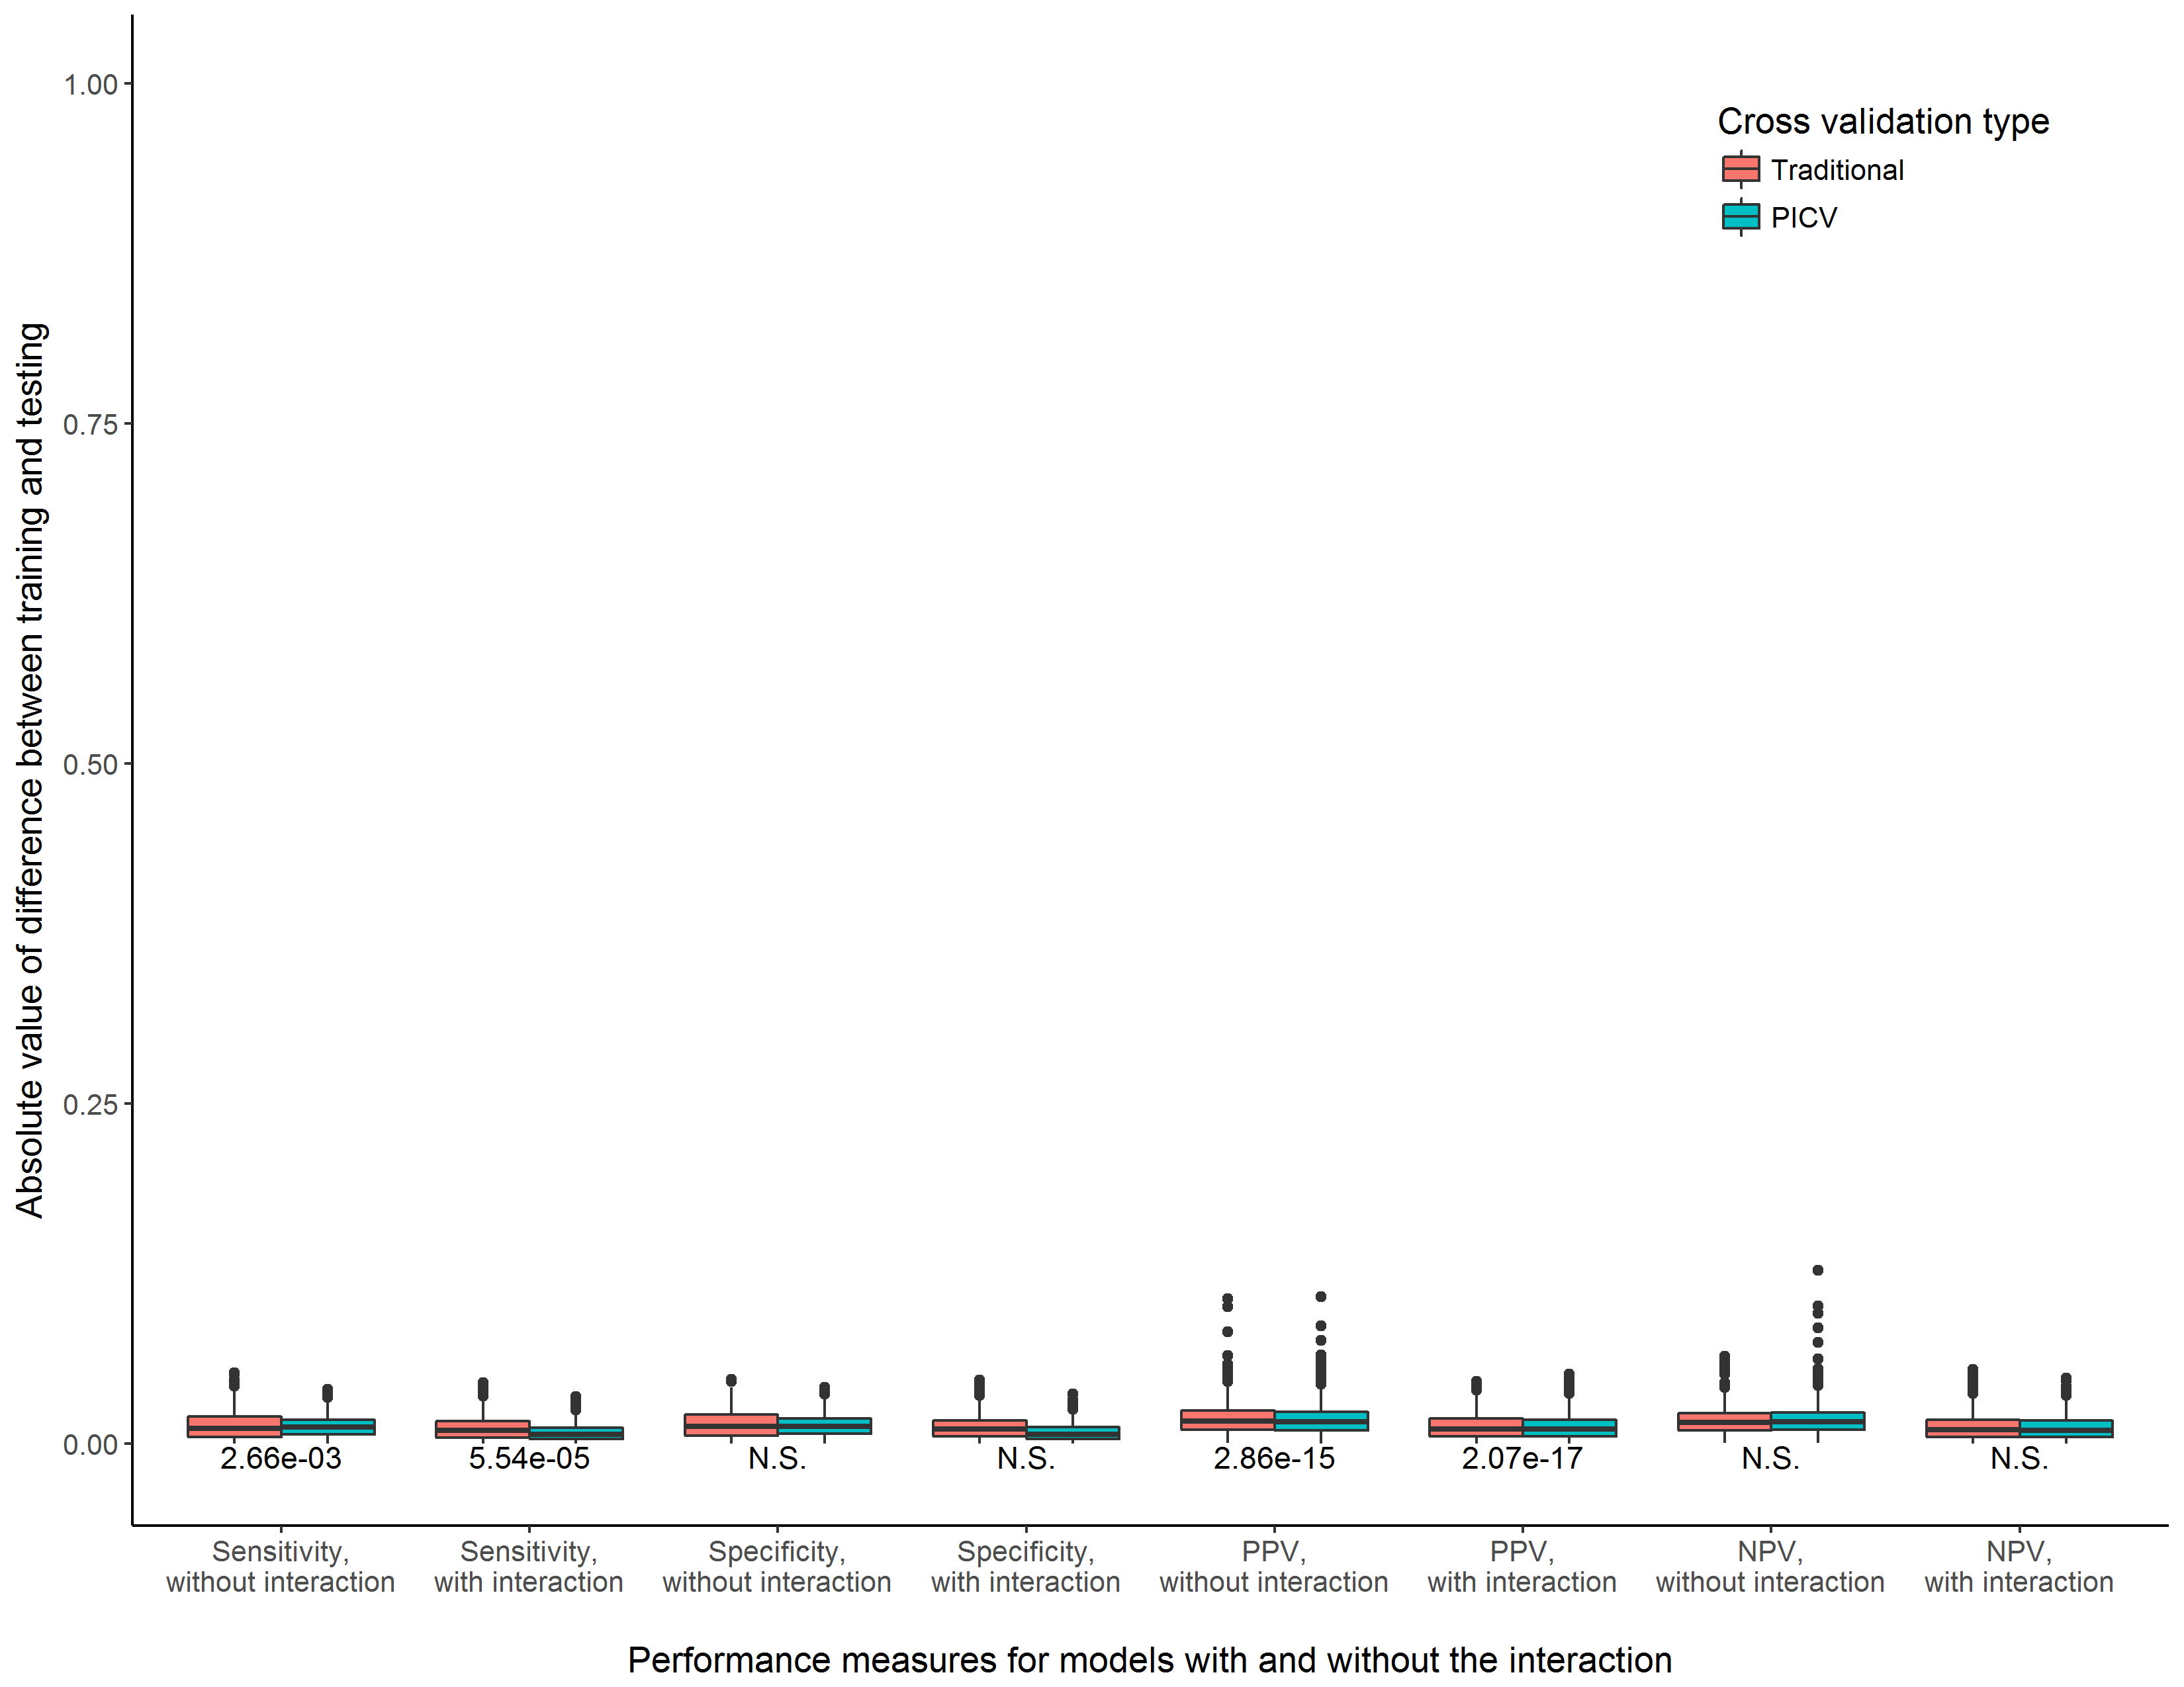

**Supplemental Figure 23.** Consistency of training and testing performance measures for models with and without the interaction term, comparing a traditional cross validation procedure to PICV. Experimental scenario 8, n = 10000

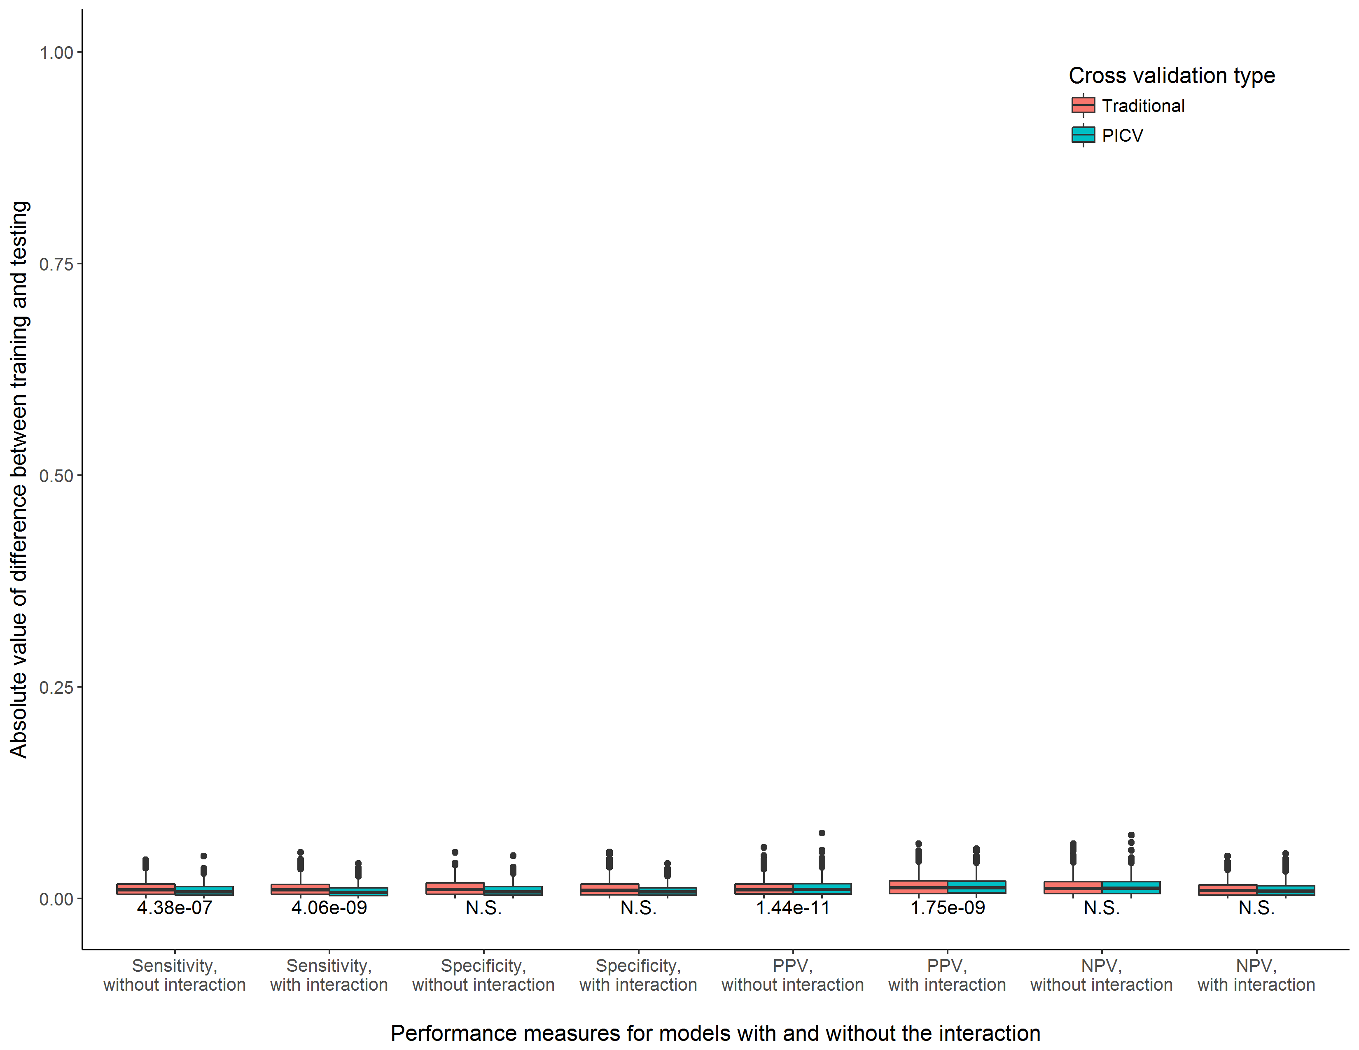

**Supplemental Figure 24.** Consistency of training and testing performance measures for models with and without the interaction term, comparing a traditional cross validation procedure to PICV. Experimental scenario 9, n = 10000

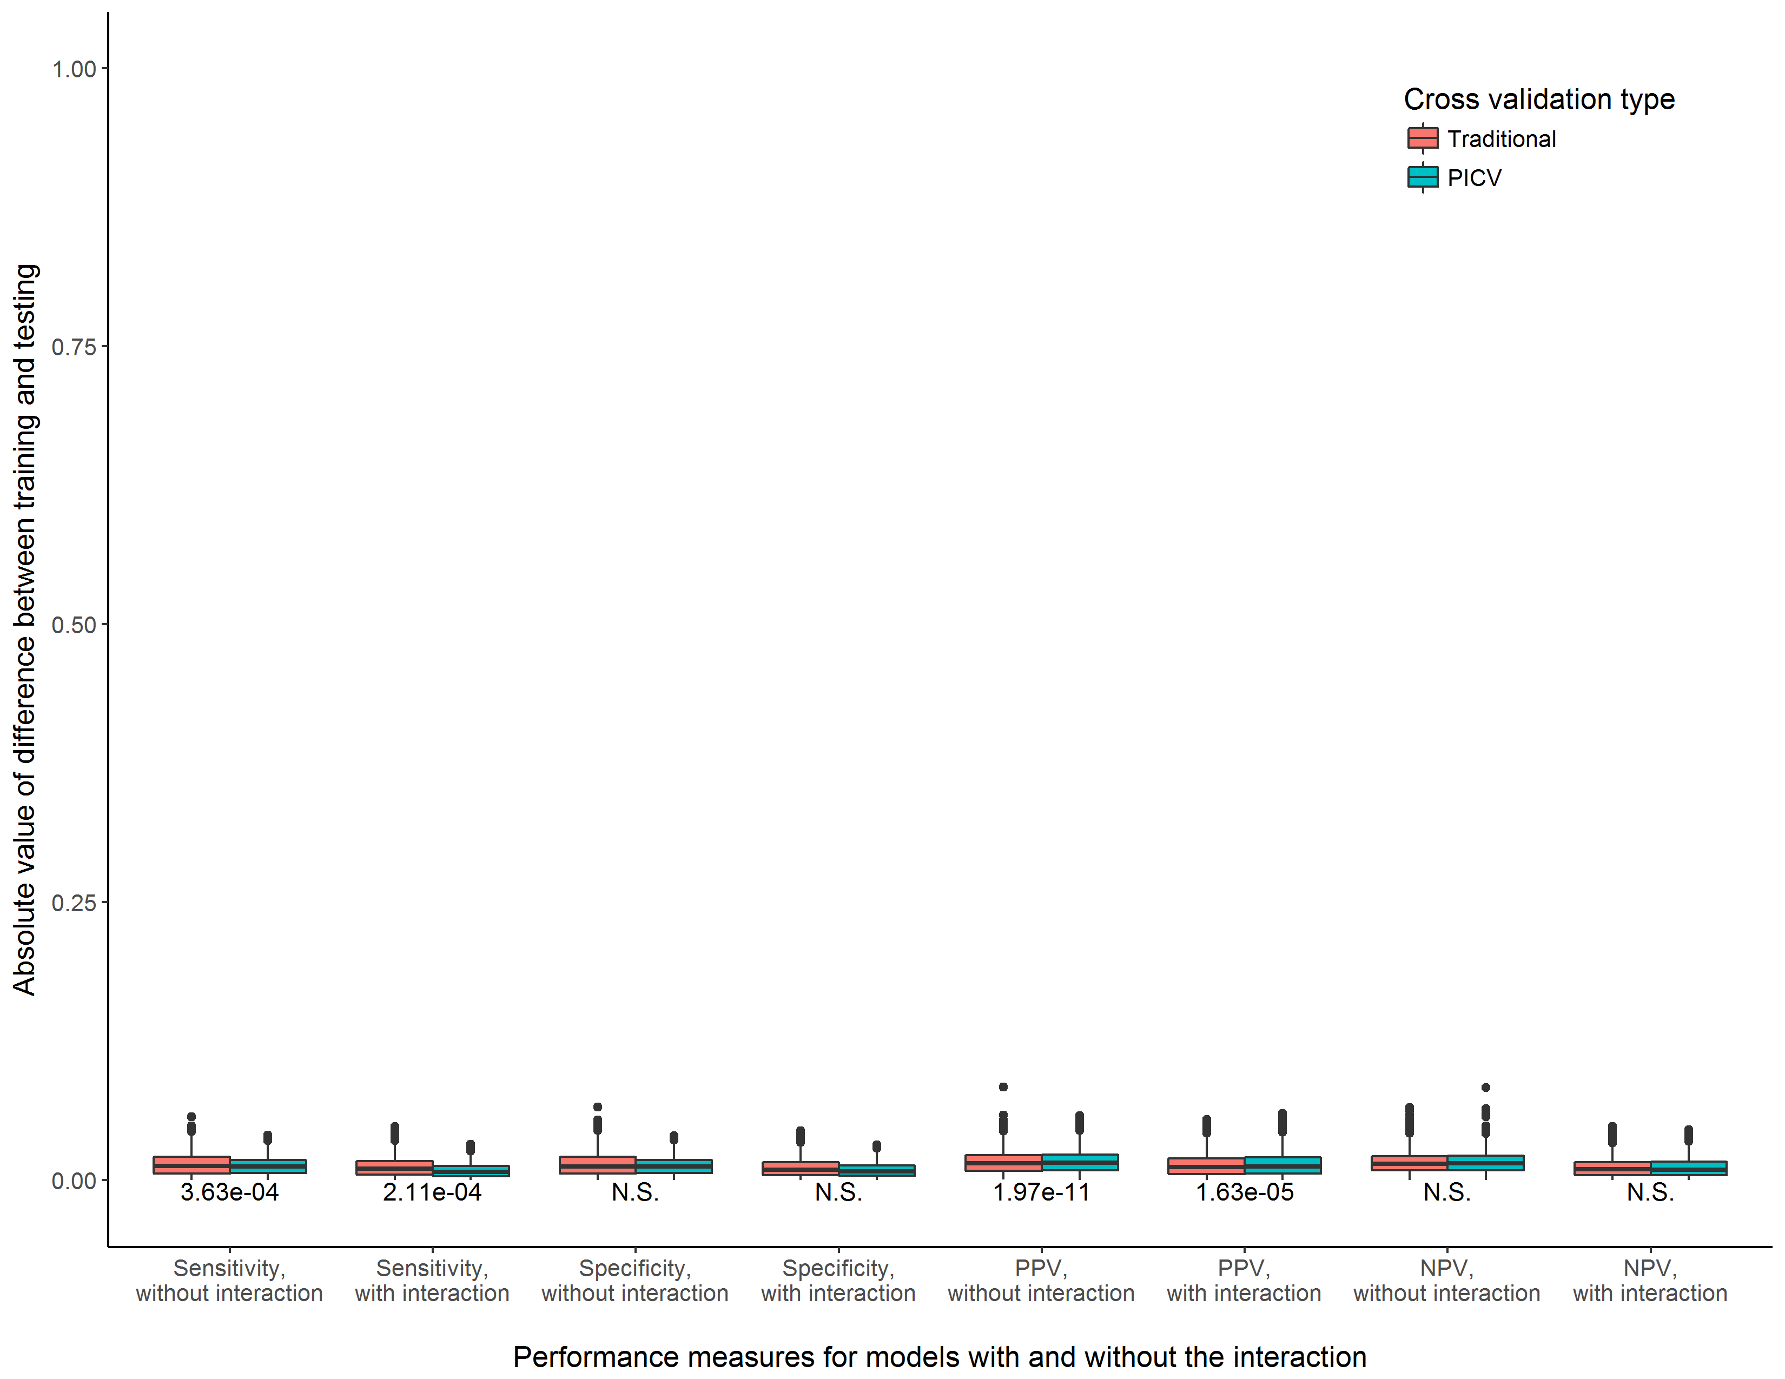

**Supplemental Figure 25.** Consistency of training and testing performance measures for models with and without the interaction term, comparing a traditional cross validation procedure to PICV. Experimental scenario 10, n = 10000

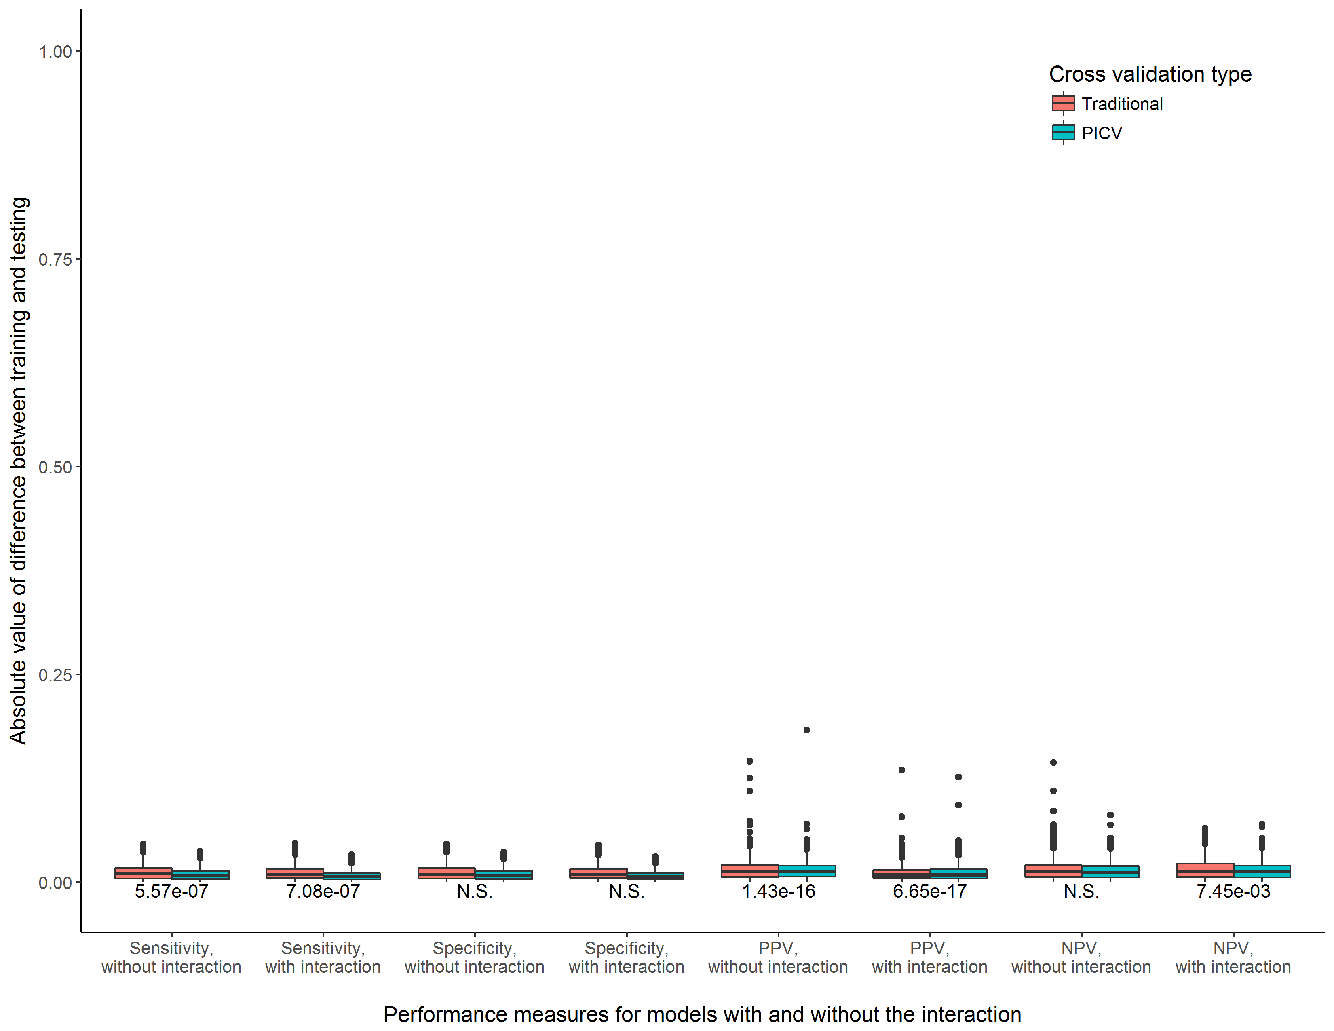

**Supplemental Figure 26.** Consistency of training and testing performance measures for models with and without the interaction term, comparing a traditional cross validation procedure to PICV. Experimental scenario 11, n = 10000

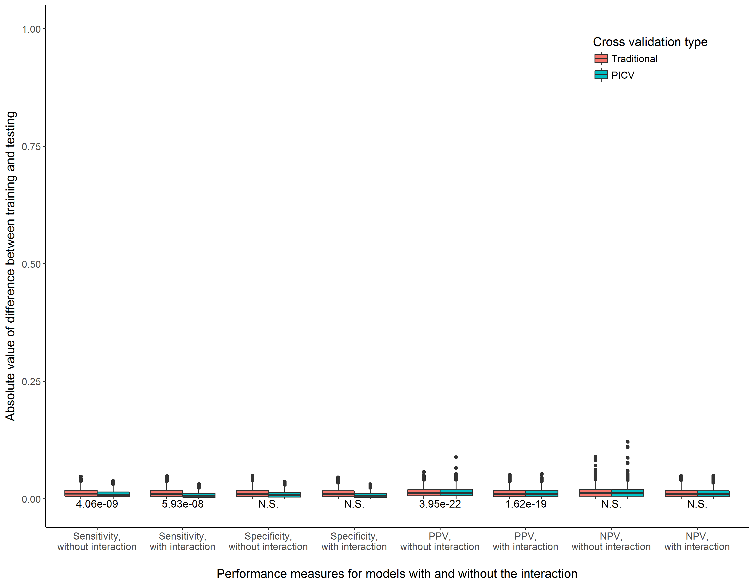

**Supplemental Figure 27.** Consistency of training and testing performance measures for models with and without the interaction term, comparing a traditional cross validation procedure to PICV. Experimental scenario 12, n = 10000

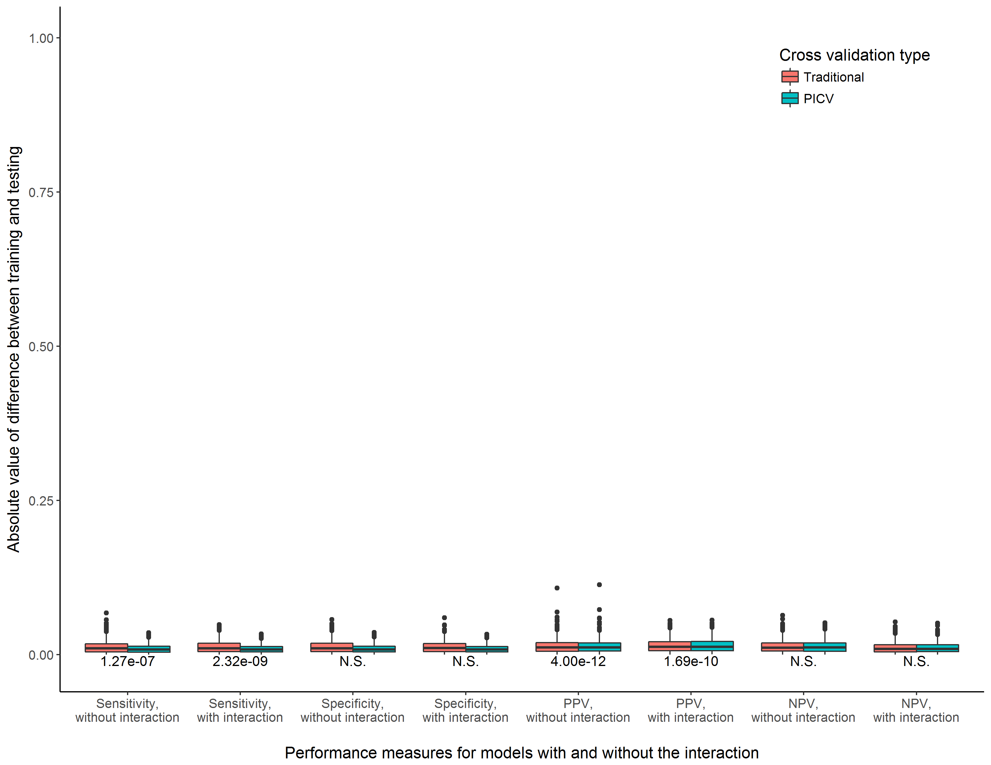

**Supplemental Figure 28.** Consistency of training and testing performance measures for models with and without the interaction term, comparing a traditional cross validation procedure to PICV. Experimental scenario 13, n = 10000

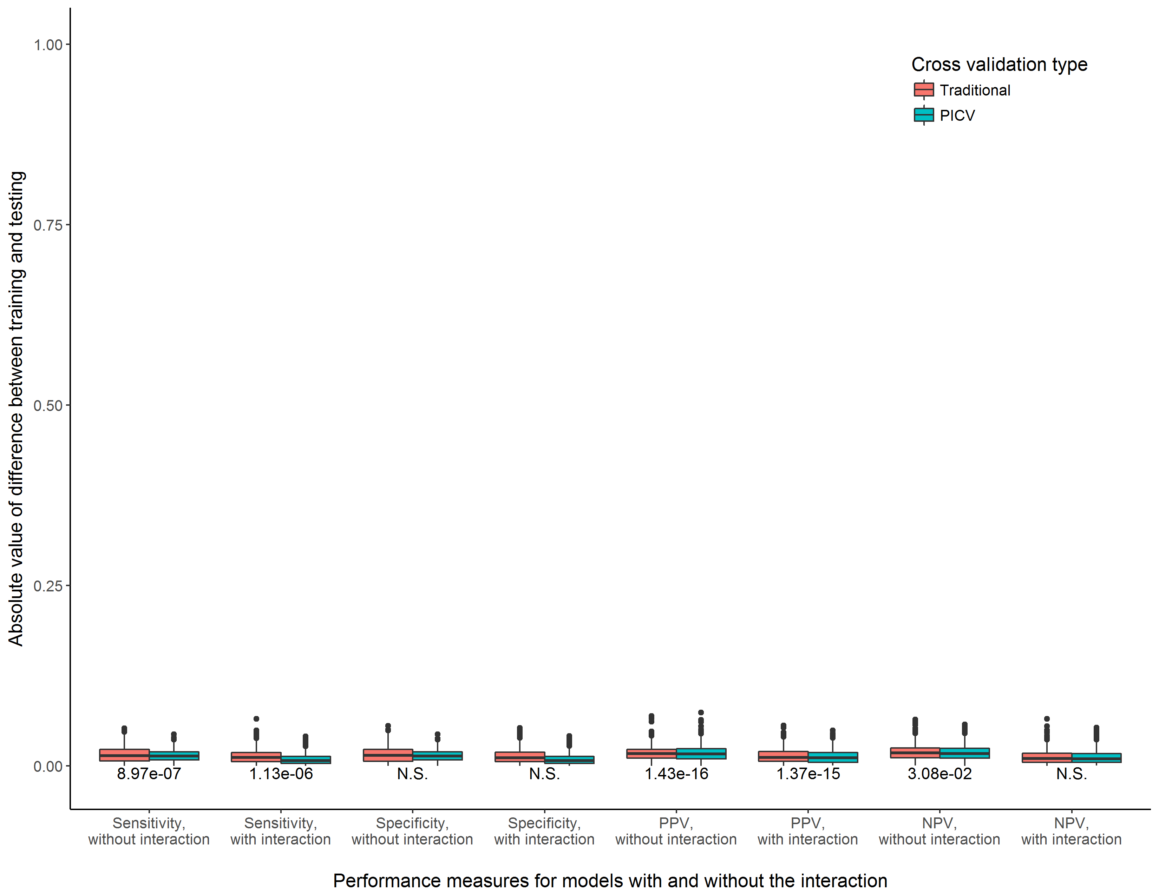

**Supplemental Figure 29.** Consistency of training and testing performance measures for models with and without the interaction term, comparing a traditional cross validation procedure to PICV. Experimental scenario 14, n = 10000

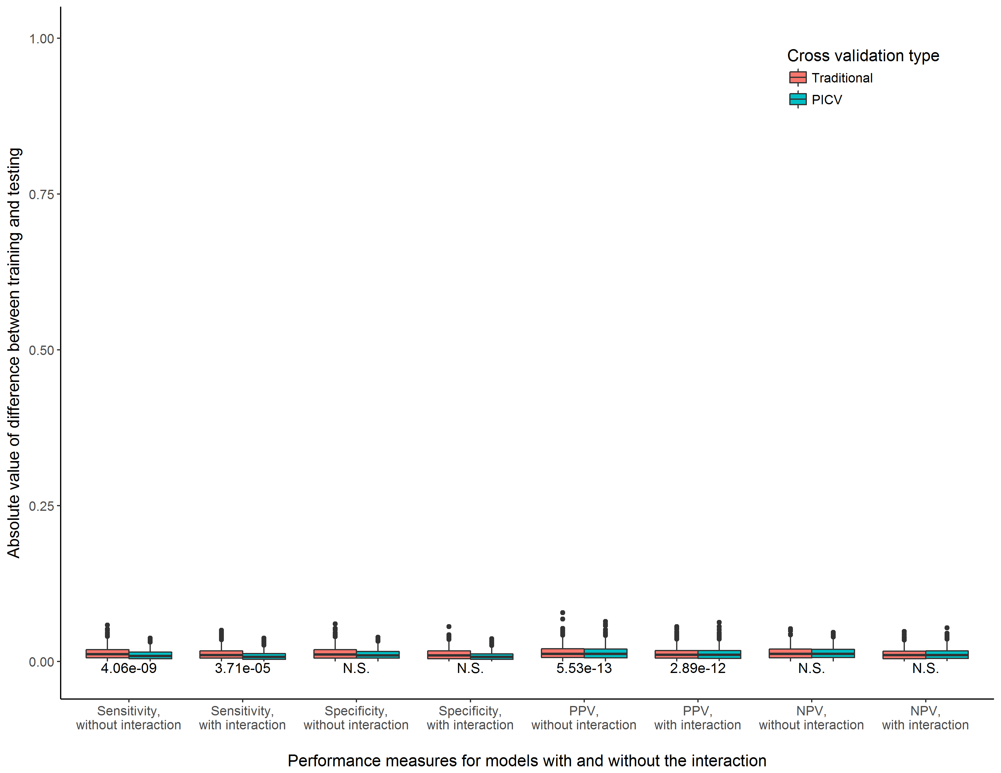

**Supplemental Figure 30.** Consistency of training and testing performance measures for models with and without the interaction term, comparing a traditional cross validation procedure to PICV. Experimental scenario 15, n = 10000

|  |  |  |  |  |  |  |  |  |
| --- | --- | --- | --- | --- | --- | --- | --- | --- |
| Measure,  Model  Scenario | Sensitivity, without interaction | Sensitivity, with interaction | Specificity, without interaction | Specificity, with interaction | PPV, without interaction | PPV,  with interaction | NPV, without interaction | NPV,  with  interaction |
| SNP1 MAF: 0.1  SNP2 MAF: 0.1 | 8.60e-06 | 1.75e-04 | N.S. | N.S. | 4.12e-10 | 4.06e-09 | N.S. | N.S. |
| SNP1 MAF: 0.2  SNP2 MAF: 0.1 | 6.92e-06 | 2.47e-05 | N.S. | 2.68e-02 | 3.03e-20 | 9.55e-22 | 4.35e-02 | N.S. |
| SNP1 MAF: 0.2  SNP2 MAF: 0.2 | 9.27e-09 | 3.03e-05 | N.S. | N.S. | 5.01e-14 | 5.92e-15 | 2.73e-02 | N.S. |
| SNP1 MAF: 0.3  SNP2 MAF: 0.1 | 2.27e-06 | 1.20e-03 | N.S. | N.S. | 1.74e-14 | 2.81e-13 | N.S. | N.S. |
| SNP1 MAF: 0.3  SNP2 MAF: 0.2 | 6.65e-17 | 4.12e-10 | N.S. | N.S. | 1.48e-21 | 1.07e-19 | N.S. | 1.46e-02 |
| SNP1 MAF: 0.3  SNP2 MAF: 0.3 | 5.56e-06 | 2.10e-07 | N.S. | N.S. | 1.75e-09 | 3.07e-16 | N.S. | N.S. |
| SNP1 MAF: 0.4  SNP2 MAF: 0.1 | 8.97e-07 | 4.54e-05 | N.S. | N.S. | 7.73e-13 | 1.00e-13 | N.S. | N.S. |
| SNP1 MAF: 0.4  SNP2 MAF: 0.2 | 2.66e-03 | 5.54e-05 | N.S. | N.S. | 2.86e-15 | 2.07e-17 | N.S. | N.S. |
| SNP1 MAF: 0.4  SNP2 MAF: 0.3 | 4.38e-07 | 4.06e-09 | N.S. | N.S. | 1.44e-11 | 1.75e-09 | N.S. | N.S. |
| SNP1 MAF: 0.4  SNP2 MAF: 0.4 | 3.63e-04 | 2.11e-04 | N.S. | N.S. | 1.97e-11 | 1.63e-05 | N.S. | N.S. |
| SNP1 MAF: 0.5  SNP2 MAF: 0.1 | 5.57e-07 | 7.08e-07 | N.S. | N.S. | 1.43e-16 | 6.65e-17 | N.S. | 7.45e-03 |
| SNP1 MAF: 0.5  SNP2 MAF: 0.2 | 4.06e-09 | 5.93e-08 | N.S. | N.S. | 3.95e-22 | 1.62e-19 | N.S. | N.S. |
| SNP1 MAF: 0.5  SNP2 MAF: 0.3 | 1.27e-07 | 2.32e-09 | N.S. | N.S. | 4.00e-12 | 1.69e-10 | N.S. | N.S. |
| SNP1 MAF: 0.5  SNP2 MAF: 0.4 | 8.97e-07 | 1.13e-06 | N.S. | N.S. | 1.43e-16 | 1.37e-15 | 3.08e-02 | N.S. |
| SNP1 MAF: 0.5  SNP2 MAF: 0.5 | 4.06e-09 | 3.71e-05 | N.S. | N.S. | 5.53e-13 | 2.89e-12 | N.S. | N.S. |

**Supplemental Table 1.** Summary of performance measures across minor allele frequency combinations, n = 10000.